Tutorial for Texture Maker 2.5 or above.

Note:- Texture Maker is a texture creation tool by Tobias Reichert.
For further product information please visit the official
site at http://www.texturemaker.com

All textures produced with Texture Maker.

Prerequisites: Texture Maker 2.5 or above.
Knowledge of the programs interface.

Steps: 10.
Difficulty: Intermediate.

Using Masks To Apply Functions.
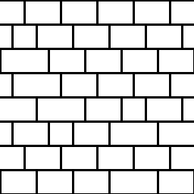

Step 1.

This tutorial covers the basics of using masks to apply
the various functions of Texture Maker to only parts of a
texture.

Lets start by opening an already produced texture that we
want to modify, for this tutorial I’m using the one shown
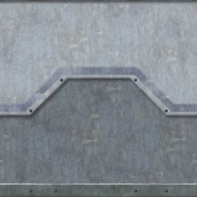
here:

Now what I want to do to this texture is add some scratches
to only the lower dark grey area.

For this I’m going to use a mask, a black & white texture,
the black part will signify what area I’m modifying:



Step 1 - Continued.

To produce the mask set the original texture to “SRC”:
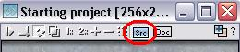

Then create a new texture with a white background and the
same dimensions as your original texture.

On the new texture turn “Snap Surface” on:
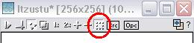

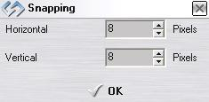

Set the grid size to 8 x 8 and then click
the “OK” button.

Then activate “Show Source Texture in Background”:
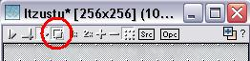

Expand the “Basic” group under “Function Selection” and
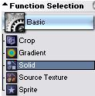
select “Solid”:

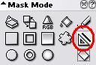

Set the “Mask Mode” to the “Line” tool:

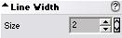
And the “Line Width” to “2”.

Tick the “Boolean Mask” and un-tick the “Antialiasing”
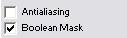
feature:

Step 1 - Continued.
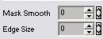
Set “Mask Smooth” and “Edge Size” to “0”:

Draw the borders of the area you want to change:
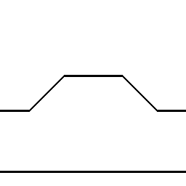

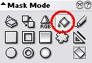

Fill the rest of the area using the
“Flood Fill” tool under “Mask Mode”:

Your result should resemble the image below:

Step 2.

Create a new textures just as before.

Expand the “Noise” group under “Function Selection” and
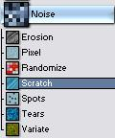
select “Scratch”:

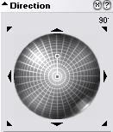

Set the direction and length of the
scratches on the “Direction Wheel”,
I’ve set it to 90 DEG and half length:

Apply to the newly created texture.

Step 3.

Using “Quick Texture Mixer” drag from the scratches texture
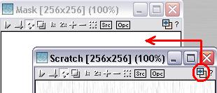
to the mask:

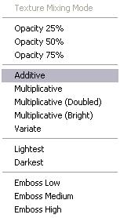

Select “Additive” from the pop-up menu:

Step 3 - Result.

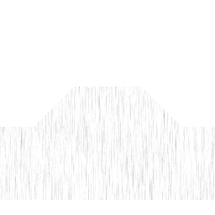

Step 4.

Drag “Quick Texture Mixer” from the mask to the original
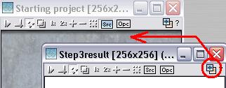
Texture:

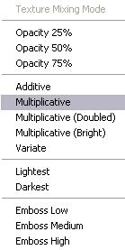

Select “Multiplicative” from the pop-up menu:

Step 4 - Result.
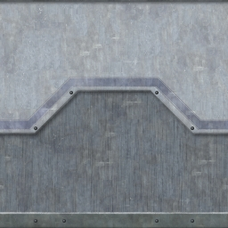

Step 5.

In this next example we are going to brighten an area of
an already existing texture.

Here is the texture I’m going to use:

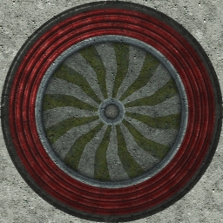

I created a mask just as in the first example only this time with the “Mask Mode” set to
“Circle”.

The mask can be seen at the top of the next page.

Step 5 - Result.
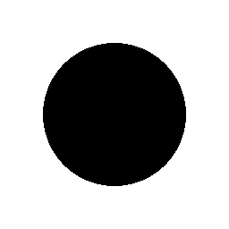

Step 6.

The first thing we are going to do is “Invert” the mask.
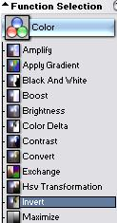
Expand the “Colour” group under “Function Selection”
and select “Invert”:

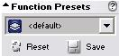
Reset the “Function Presets”
by clicking on the
“Reset” button:



Apply to the mask
to get this result:

Step 7.

Set the mask texture as “OPC”:
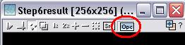

Step 8.

Select “Brightness” from the “Colour” group under “Function
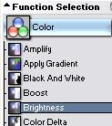
Selection”:

Apply to the original texture.

Here are the before and after examples:

Before: After:
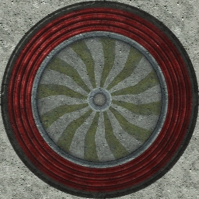

Step 9.

Now for a third example, only this time a brick type
pattern.

Here is the mask:

Step 10.

Expand the “Generator” group under “Function Selection” and
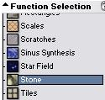
select “Stone”:

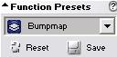

Set the “Function Presets” to “Bumpmap”:

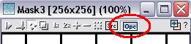

Active “OPC” on the brickwork mask:

Create a new texture with a white background and the same dimensions as the brickwork
mask texture and apply the function to it.

You can see the result at the top of the next page.

Step 10 - Result.
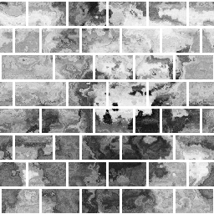

That concludes this tutorial.
_______________________________________________________________________

