Tutorial for Texture Maker 2.5 or above.

Note:- Texture Maker is a texture creation tool by Tobias Reichert.
For further product information please visit the official
site at http://www.texturemaker.com

All textures produced with Texture Maker.

Prerequisites: Texture Maker 2.5 or above.
Knowledge of the programs interface.

Steps: 9.
Difficulty: Intermediate.

Applying Emboss Details.

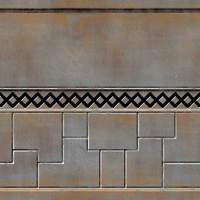

Step 1.

Lets begin by opening an already existing texture:
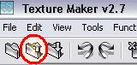

The “Open” dialogue box opens:
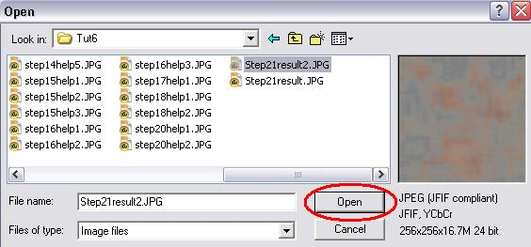

I’m going to use the texture created in tutorial 6.

Simply select your texture from the list and then click
“Open”.

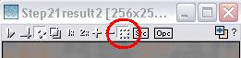
Step 2.

Turn “Snap Surface” on:

Leave the grid at the default of 16 x 16, just click the
“OK” button:
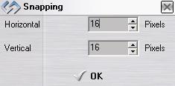

Step 3.

Under “Function Selection” expand the “Bump” group and
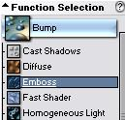
select “Emboss”:

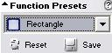

Set the “Function Presets” to “Rectangle”:

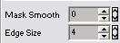

Change the “Edge Size” to four(4):

Click the “Choose” button against “Variate Map”:
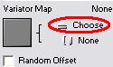

Select “Plasma Cloud” from the texture selection box:
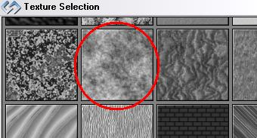

Step 4.

Draw a rectangle one grid square in height at roughly the
center of the texture.

See the top of the next page for an example.

Step 4 - Continued.
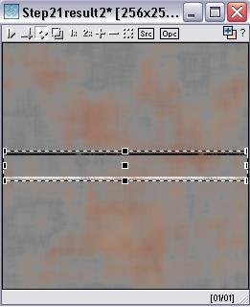

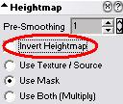
Under the “Heightmap” untick the
“Invert Heightmap” option:

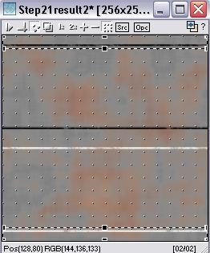

Draw another rectangle across the
texture but this time two grid
squares in height. Make it cover
the top line and the last line of
the texture:

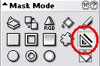
Step 5.

Change “Mask Mode” to the “Line” tool:

Set “Edge Size” to four(4), and “Line Width” to two(2):
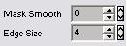
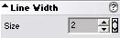


Make sure thar “Boolean Mask Opacity” is active:

Draw lines in the lower part of the texture as in my example below:
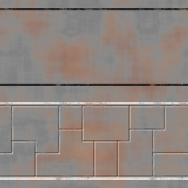

Step 6.

Now to add embossing via another method – that of masks.

Create a new texture with a white background.

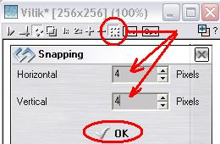
Set “Snap Surface” on
with a grid size of
4 x 4.

Then click the “OK” button:

Step 7.

Expand the “Basic” group under “Function Selection” and
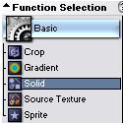
choose “Solid”:

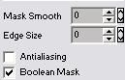

Set “Boolean Mask Opacity” and turn “Antialiasing” off,
also ensure that “Mask Smooth” and “Edge Size” are
set at zero(0):
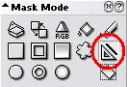

Choose the “Line Tool” as the “Mask Mode”.

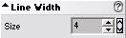
Set the “Line Width” to four(4):

Draw out the pattern on the empty texture as in my example below:

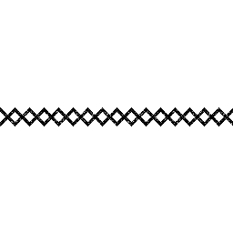

Step 8.

Expand the “Bump” group under “Function Selection” and
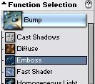
select “Emboss”:

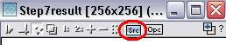
Set “SRC” on the pattern texture:

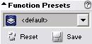
“Function Presets” needs to be reset to “<default>”

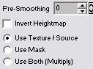

Set “Heightmap” to “Use Texture/Source”.

Apply to the texture to obtain a result similar to the one shown below:

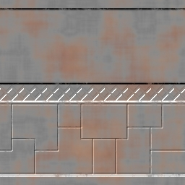

Step 9.

Now to add the pattern to the metal texture.

Drag “Quick Texture Mixer” from the pattern texture to the
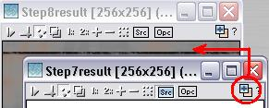
metal texture:

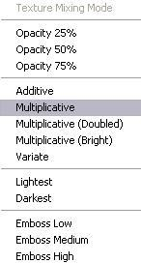

Select “Multiplicative” from the pop-up menu:

Here is the result:
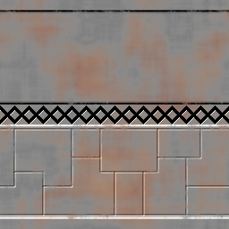

That concludes this tutorial.
______________________________________________________________________________________

