Tutorial for Texture Maker 2.5 or above.

Note:- Texture Maker is a texture creation tool by Tobias Reichert.
For further product information please visit the official
site at http://www.texturemaker.com

All textures produced with Texture Maker.

Prerequisites: Texture Maker 2.5 or above.
Knowledge of the programs interface.

Steps: 7.
Difficulty: Intermediate.

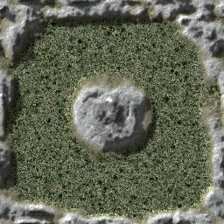
Creating A Topmap And Shadow Map From A Heightmap.

Step 1.

Lets begin by creating a new texture by clicking on the new texture button on the TMAK toolbar(as shown in the image below).

The create texture dialogue box appears:
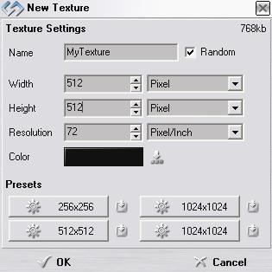
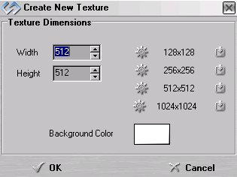

Note that there are two different images for the texture creation dialogue box as shown above. The lefthand image is for versions prior to 2.7 while the righthand image is for version 2.7 and above.

Set the "Background Color" to "Black" and the "Texture Dimensions" to "Width & Height = 512".

In all these Texture Maker tutorials the creation size is 512x512. This is because it is easier to work at the larger resolutions. You can always resize the texture once you have completed it. If your screen size limits you from working at this size simply use the next one down, all these tutorials can just as easily be followed with a size of 256x256.

Once you are happy with the settings simply click the "OK" button to proceed.

Step 2.

Under “Function Selection” expand the “Generator” group
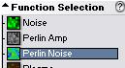
select “Perlin Noise”:

Then select “Heightmap Mountains” from the “Function
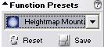
Presets”:

Draw out your design remembering that white indicates
high elevations and black low.

I’m using a simple layout that can be seen below:

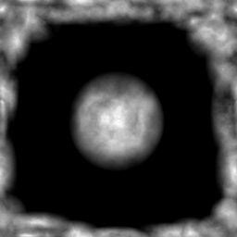

Step 3.

Once you have your heightmap all that is needed are the base textures that will make up your topmap. The textures shown on the next page are poor but adequate for this tutorial. The better your base textures the better the finished product.

Step 3 - Continued.

These first two textures will form the mountains:

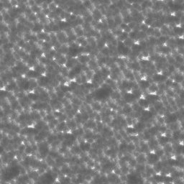
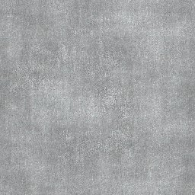

The last two will form the lower elevations of the finished
topmap:

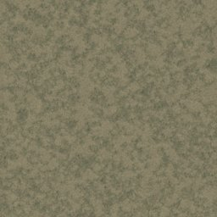
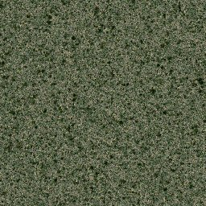

For this tutorial I’m only using 4 base textures but you
can use a maximum of 8.

Step 3 - Continued.

Click on the “Advanced Multi Texture Mixer” button on the
toolbar:
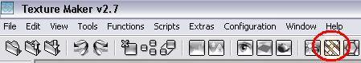

The mixer window should then display:

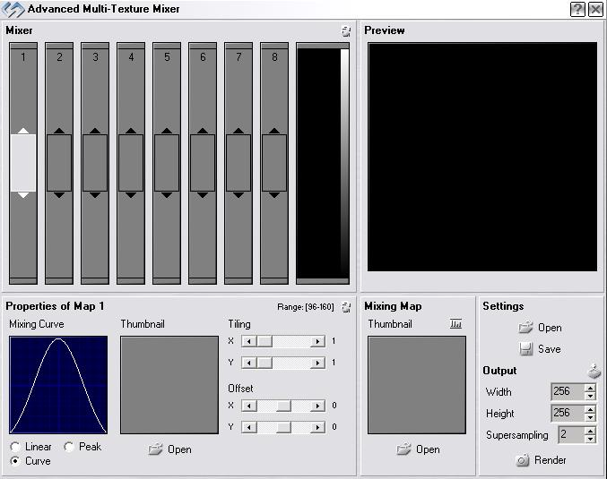

Towards the bottom of the mixer window as can be seen in
the image above is the “Mixing Map” selection box.

The “Mixing Map” controls how the textures will be merged.

Step 3 - Continued.
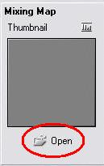
Click on the “Open” button beneath
the thumbnail:

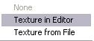

Select from the pop-up menu.

From the texture selection window:
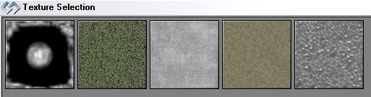

Select the heightmap texture you created earlier.

The thumbnail in the “Mixing Map” will update with your
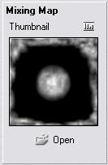
selection:

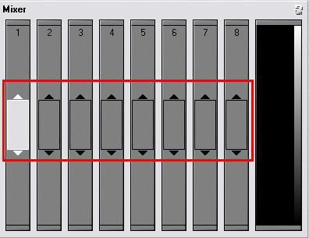
Step 4.

The image shown above shows the eight slots to which
textures can be assigned. It also shows that no textures
are currently selected and that slot 1 is currently
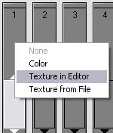
active.

Right click on slot 1 to
access the pop-up menu:

Then select “Texture
In Editor”.

From the texture selection window click on the texture that
will form the lowest point of the topmap, I’m going to use
the darker of the two green textures.
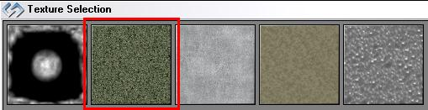

Step 5.

Repeat the process to add the remaining textures into the
other slots. I’m going to place the lighter green texture
in slot 2, the light gray in slot 3, and the ripple effect
in slot 4.
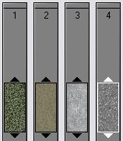

Once all the textures are loaded its time to make them
merge. Slide the texture in slot one, all the way down
to the bottom.

Then move slot 2 so that it partly overlaps slot 1.

Move slot three so that it overlaps slot 2 and slot 4 must
over lap slot 3 and be at the top of the slot. Refer to
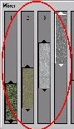
the image shown below for reference.

The preview image shows the result of your merging in
realtime.

The arrows above and below each of the selected textures
can be dragged to have the texture take up more of the
merge. Play around with it to see what effect it makes.
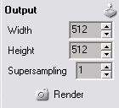
Once you are happy with the result.
Set the output options to width
and height = 512 and what ever
“Supersampling” level suits your
needs at the time.

Step 5 - Continued.

Once all the settings are complete click the “Render”
Button, to get a result similar to the one below:
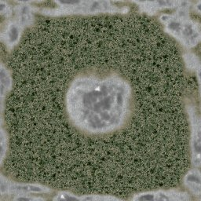

Step 6.

Now to add a little more depth to the topmap.

Drag “Quick Texture Mixer” from the heightmap to the
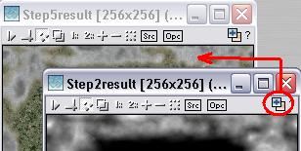
topmap:

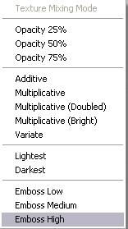

From the pop-up menu select “Emboss High”.

Step 6 - Continued.

Repeat the procedure until you have the effect you are
looking for or something similar to the one below:
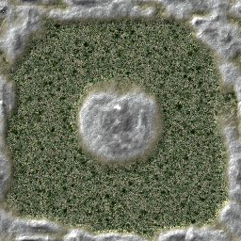

Step 7.

Set the heightmap texture as “SRC”:
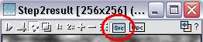

Now we are going to use the heightmap to create a shadow
map.

There are two ways to do the shadow map.

1 – Hard bake them onto the topmap texture.
2 – Create a separate texture for the shadows.

As it’s always best to begin at the beginning lets bake
the shadows onto the topmap.

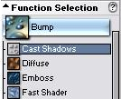

Expand the “Bump” group under “Function Selection”
and select “Cast Shadows”:

Step 7 - Continued.

Set the “Function Presets” to “<default>” by clicking on
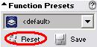
the “Reset” button:

Apply this to the topmap to see the result.

Now lets create the same shadow as a separate texture.

Create a new texture with a white background.

Apply the “Cast Shadows” function to the new texture.
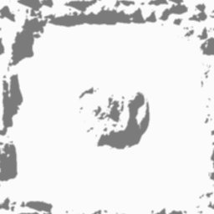

That concludes this tutorial.
_______________________________________________________________________

