Tutorial for Texture Maker 2.5 or above.

Note:- Texture Maker is a texture creation tool by Tobias Reichert.
For further product information please visit the official
site at http://www.texturemaker.com

All textures produced with Texture Maker.

Prerequisites: Texture Maker 2.5 or above.
Knowledge of the programs interface.

Steps: 21.
Difficulty: Intermediate.

Creating A Base Metal Texture For Rusty Projects.

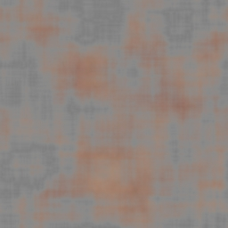

Step 1.

Lets begin by creating a new texture by clicking on the new texture button on the TMAK toolbar(as shown in the image below).

The create texture dialogue box appears:

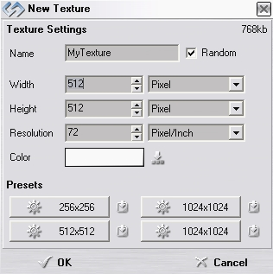
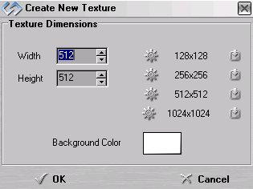

Note that there are two different images for the texture creation dialogue box as shown above. The lefthand image is for versions prior to 2.7 while the righthand image is for version 2.7 and above.

Set the "Background Color" to "White" and the "Texture Dimensions" to "Width & Height = 512".

In all these Texture Maker tutorials the creation size is 512x512. This is because it is easier to work at the larger resolutions. You can always resize the texture once you have completed it. If your screen size limits you from working at this size simply use the next one down, all these tutorials can just as easily be followed with a size of 256x256.

Once you are happy with the settings simply click the "OK" button to proceed.

Step 2.

Under “Function Selection” expand the “Generator” group and
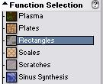
select “Rectangles”:

Apply the function to the new texture to obtain a result similar to the one below:
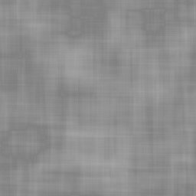

Step 3.

Create another texture exactly as you did in step 1.

Step 4.
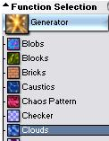
Select “Clouds” from the “Generator” group:

Step 4 - Continued.

Set the “Foreground” colour to a dark brown, and the
“Background” to a lighter shade of brown:

Apply to the newly created and currently blank texture:

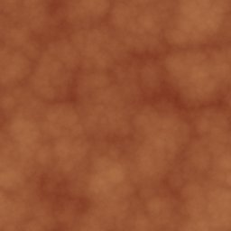

Step 5.

On the texture you filled with the “Rectangles” function,
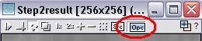
set “OPC”:

Step 6.

Expand the “Filter” group under “Function Selection” and
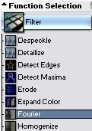
Select “Fourier”:

Apply effect to the texture.

Step 7.

Make sure the “Rectangles” texture is active.
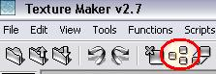
Clone the “Rectangles” texture:

Step 8.

Remaining in the “Filter” group under “Function Selection”
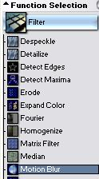
select “Motion Blur”:

Apply the effect to the cloned “Rectangles” texture.

Step 9.

Drag “Quick Texture Mixer” from the cloned texture to the
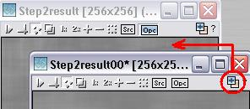
“Rectangles” texture:

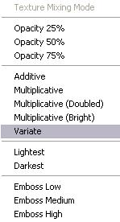
Step 9 - Continued.

Select “Variate” from the pop-up menu:

Step 10.

Close the cloned “Rectangles” texture without saving as we
have no further use for it.
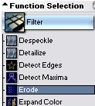
Step 11.

Select “Erode” from the “Filter” group:

Apply to the “Rectangles” texture, you should get a result
similar to one shown at the top of the next page.

Step 11 - Continued.

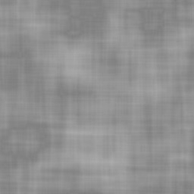

Step 12.

From “Function Selection” expand the “Noise” group and
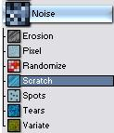
select “Scratch”:

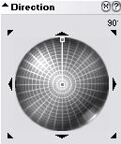

Set the angle of the scratches via the “Direction Wheel” to 90DEG:

Then set the length of the scratches by
shortening the angle indicator:
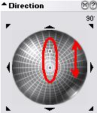

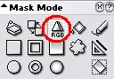
Step 12 - Continued.

Set the “Mask Mode” to “RGB”:

Click on the different shades of the rectangles texture to
apply the function to that colour.

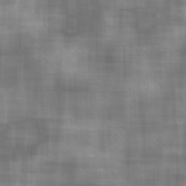

Step 13.

Change the angle of the scratches, I’m using 45DEG:
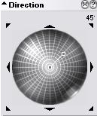
Apply the scratches to the rectangles
texture as in step 12.
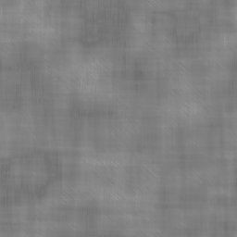

Step 14.

Click on the “Advanced Multi Texture Mixer” button on the
toolbar:
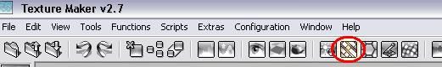

The “Advanced Multi Texture Mixer” window opens:
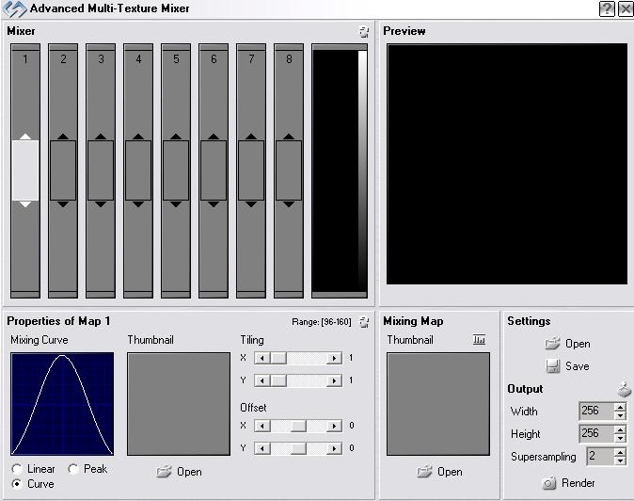

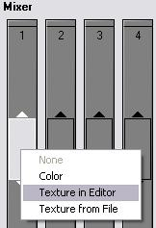

Right click on the first box in the “Mixer”
and select “Texture In Editor”:

Step 14 - Continued.

From the “Texture Selection” window select the rectangles
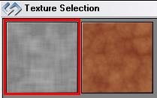
texture:

Do the same again in the second box but select the clouds
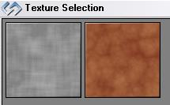
texture:

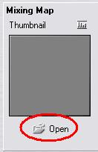
Step 15.

Click the “Open” button under the
“Mixing Map” portion of the window:

Select “Texture From Editor”.
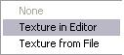

Pick the rectangles texture from the selection window:
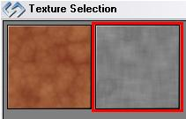

Step 16.

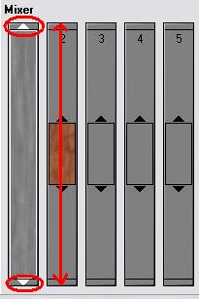

Using the resize arrows at the top and
bottom of the first texture in the mixing
area, click and drag until the texture
fills the entire area:
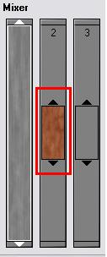

Slide the clouds texture up and down,
until you get a result in the preview
box that look similar to the one shown
below:

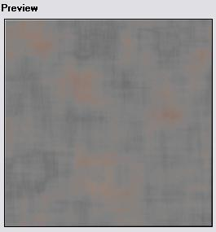

Step 17.

Once you have the mix of textures looking how you want set
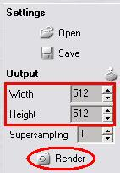
the output dimensions to 512 x 512:

Click the “Render” button:

Step 18.

The “Output” window appears:
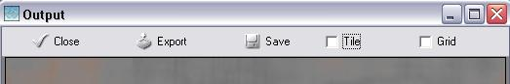

If you are happy with the output click the “Export” button:
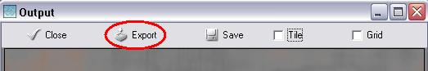

Close the “Output” window and “Advanced Multi Texture
Mixer”

Step 19.

Close the clouds texture without saving.

Step 20.

In “Function Selection” expand the “Filter” group and
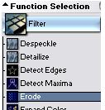
select “Erode”:

Set “OPC” to the newly rendered texture:
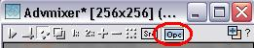

Apply the function.

Step 21.

Save both textures to whatever you wish as these are the
simple metal bases for rusty and non-rusty projects.
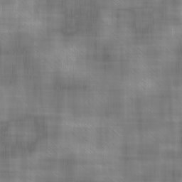

Base Metal Rusty Metal

There are many other ways to do metal this tutorial is really only showing you some of the basics of Texture Maker.

That concludes this tutorial.
_______________________________________________________________________

