Tutorial for Texture Maker 2.5 or above.

Note:- Texture Maker is a texture creation tool by Tobias Reichert.
For further product information please visit the official
site at http://www.texturemaker.com

All textures produced with Texture Maker.

Prerequisites: Texture Maker 2.5 or above.
Knowledge of the programs interface.

Steps: 35.
Difficulty: Intermediate.

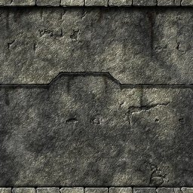
Creating A Reasonable Stone Wall.

Step 1.

Lets begin by creating a new texture by clicking on the new texture button on the TMAK toolbar(as shown in the image below).

The create texture dialogue box appears:

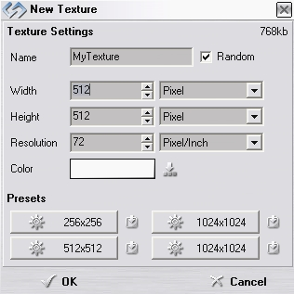
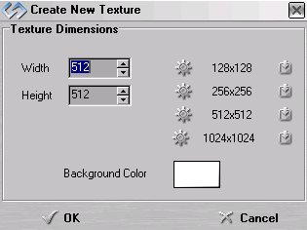

Note that there are two different images for the texture creation dialogue box as shown above. The lefthand image is for versions prior to 2.7 while the righthand image is for version 2.7 and above.

Set the "Background Color" to "White" and the "Texture Dimensions" to "Width & Height = 512".

In all these Texture Maker tutorials the creation size is 512x512. This is because it is easier to work at the larger resolutions. You can always resize the texture once you have completed it. If your screen size limits you from working at this size simply use the next one down, all these tutorials can just as easily be followed with a size of 256x256.

Once you are happy with the settings simply click the "OK" button to proceed.

Step 2.

Under “Function Selection” expand the “Basic” group and
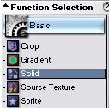
select “Solid”:

Step 3.

Turn “Snap Surface” on. The “Snap Surface” icon is located
beneath the textures title and is the dotted outline of a
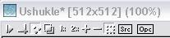
square:

Live the grid sizing at the default of 16x16 as we are only
using the grid as a guide there is no need to use a smaller
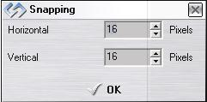
more precise grid:

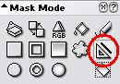
Step 4.

Choose the “Line” tool under “Mask Mode”:

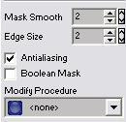
Make sure the following options are
Set or unset as needed:

“Mask Smooth” = 2
“Edge Size” = 2
“Antialiasing” = active
“Boolean Mask” = inactive

Step 4 - Continued.
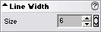
Set the “Line Width” to 6:

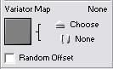

Make sure that there is no “Variator Map”
selected, the thumbnail should be empty:

If a thumbnail is shown simply click on the “None”
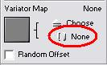
button as indicated here:

Lastly ensure that both “SRC” and “OPC” are turned off:
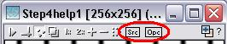

Draw out your design – here is one I’m going to use:
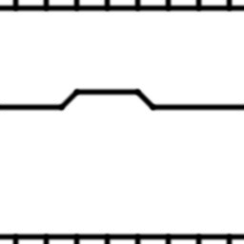

Step 5.

Save your design! I’m going to save it as Step4help1.jpg
to help me locate and add it to this tutorial.

To save a texture click on the “Save” button on the Texture
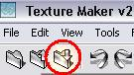
Maker toolbar:

Step 6.

Expand the “Bump” option under “Function Selection” and
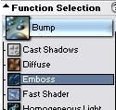
select “Emboss”:

Click the “Reset” button under “Function Presets” to clear
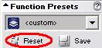
out any existing settings:

“Function Presets” needs to read “<default>”:
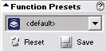

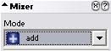

Set “Mixer” to “Add”:

Apply the function to the texture four times(x4) to obtain
a result similar to the one shown at the top of the next
page.

Save the texture once you’ve applied the function.

Step 6 - Result.

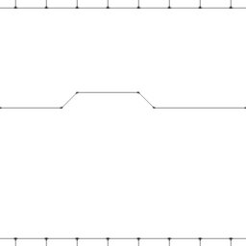

Step 7.

“Clone” the texture, the “Clone” button is located on
the toolbar and looks like three small boxes, one on
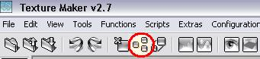
the left and two on the right:

An exact clone of your texture will appear. We are going
to use this clone for the next few steps so leave your
original texture alone for now.

Step 8.

Under “Function Selection” return to the “Basic” group and
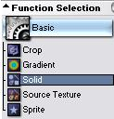
Select “Solid”:

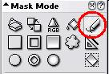
Step 8 - Continued.

Select “Freehand Pen” under “Mask Mode”:

Leave the other settings as they were when you drew the
original texture.

Redraw the design and allow yourself to drift slightly
As you are trying to make the lines look less regular.
Be sure to not drift too much or the original lines will
still be evident.
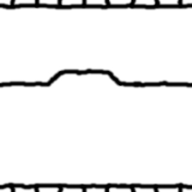

You should end up
with something
similar to this:

Step 9.
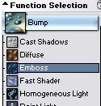
Return to the “Bump” group and select
“Emboss”:

Apply the “Emboss” function four times (x4).

The result can be seen at the top of the next page.

Step 9 - Result.

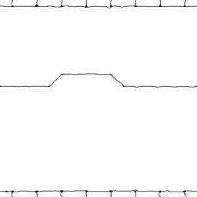

Step 10.

Close your original texture and then save the cloned one and overwrite the original. We only really needed the original in case we really messed up the traced version and needed to start again.

Step 11.

“Clone” the texture as was shown in a previous step.

We are once again going to work with the cloned version.

Step 12.

Open up the “Generator” group and select “Stone”:
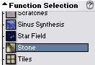

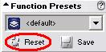
Click the “Reset” button
Under “Function Presets”:

Step 13.

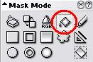
Under “Mask Mode” select the “Paint Bucket” (Fill Tool):

On the cloned texture click in the white areas:
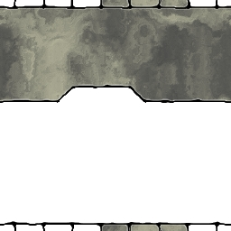

It should look similar to the image below once all the
White areas have been filled:

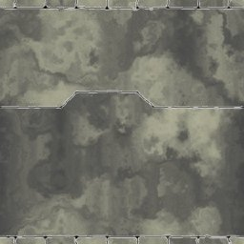

Step 14.
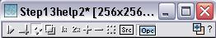
Turn “OPC” on:

Step 15.

Open the “Noise” group under “Function Selection” and
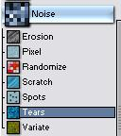
Select “Tears”:

Apply the “Tears” function to the texture twice(x2).

Step 16.
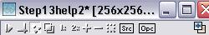
Turn “OPC” off:

Create a new texture as shown in step 1.

Apply the “Tears” function to the new texture.
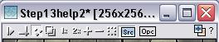
Turn “SRC” on:

The resultant texture can be seen at the top of the next
page:

Step 16 - Result.



Step 17.

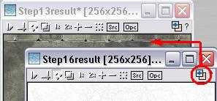
Drag “Quick Texture Mixer” from the tears texture to the
stonework texture:

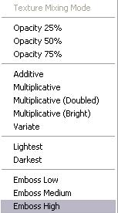

Select “Emboss High” from the pop-up menu.

Step 17 - Continued.

Repeat this procedure until you get a reasonable effect,
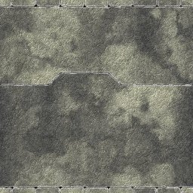
something like the this:

Step 18.

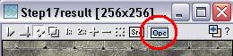
Set the stonework texture as “OPC”:

Expand the “Bump” group under “Function Selection” and
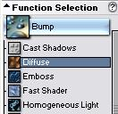
select “Diffuse”:

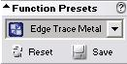

Set the “Function Presets” to “Edge Trace Metal”.

Click on a lighter area of the stonework texture to get a
result similar to the one shown at the top of the next
page.

Step 18 - Result.

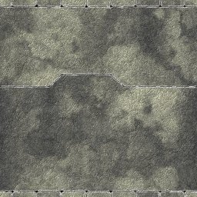

Step 19.

Remaining in the “Bump” group of “Function Selection”
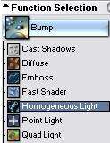
choose “Homogeneous Light”:

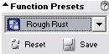
Set “Function Preset” to “Rough Rust”:

Again click on a lighter area of the stonework texture.

A sample result can be seen at the top of the next page.

Step 19 - Result.

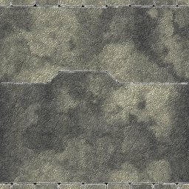

Step 20.

Select the “Variate” function from the “Bump” group:
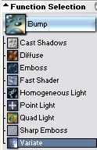

Reset “Function Presets”.
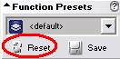

Apply the function to the texture.

You may need to apply the function more than once to get
A reasonable result.

See top of next page for a sample result.

Step 20 - Result.

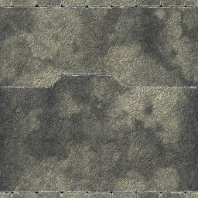

Step 21.

Deselect “OPC” on the stonework texture:
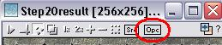

Wipe the tears texture to a white background colour.

Deselect the tears texture as “SRC”:
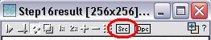

Step 22.

Expand the “Generator” group under “Function Selection” and
select “Stone”:

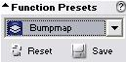
Step 22 - Continued.

Set the “Function Presets” to “Bumpmap”:

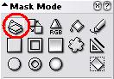
Check that the “Mask Mode” is
set to “Entire Texture”:

Apply to the empty texture.

The result is a grey scale image similar to the one shown:
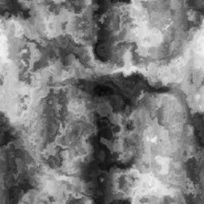

Using “Quick Texture Mixer” drag from the bumpmap texture
To the stonework texture:

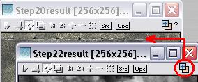

Step 22 - Continued.

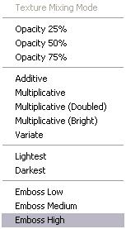
Select “Emboss High” from
the pop-up menu:

Repeat the step as many times as needed to get
the rough feel you are aiming for. Here is my
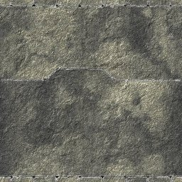
end product:

Step 23.

Wipe the bumpmap texture to a white background:
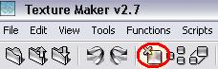

Set the “Function Presets” to “Variate” remember we are
still working with the “Wall Erosion” function in the
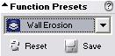
“Generator” Group.

Apply to the empty texture to get a result similar to the
one shown at the top of the next page.

Step 23 - Continued.

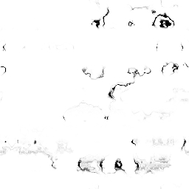

Drag “Quick Texture Mixer” from the wall erosion texture to
the stonework texture:
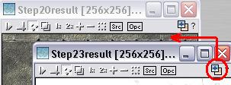

Select “Emboss High” from the
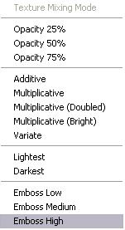
Pop-up menu:

You may need to do this more than
once to get the look you require:
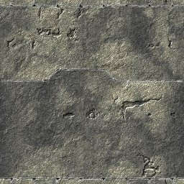

Step 23 - Continued.

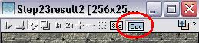
Set “OPC” on the stonework texture:

Set “SRC” on the wall erosion texture:
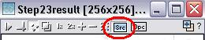

Expand the “Bump” group under “Function Selection” and
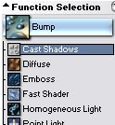
select “Cast Shadows”:

Apply to the stonework function to add a little more depth
to the erosion pattern.

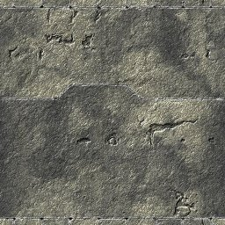

Step 24.

You have a choice here, you could just skip this step and move onto the next. You may think your stonework looks fine the way it is so this step will be superficial.

Deselect “OPC” on the stonework texture:
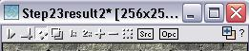

Wipe the wall erosion texture to a white background:

Expand the group “Generator” under “Function Selection” and
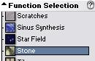
select “Stone”:

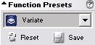

Set the “Function Presets” to “Variate”:

Apply the “Variate” function to the empty texture to get a
result similar to this:



Step 24 - Continued.

Drag “Quick Texture Mixer” from the “Variate” texture to
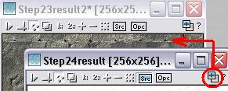
The stonework texture:

Select “Emboss High” from
The pop-up menu:
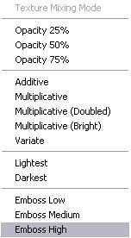

You may want to do this more than once
it all depends on personal preference.

Here is my result:
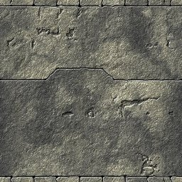

Step 25.

Close the “Variate” texture:
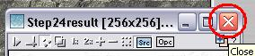

If asked to save click “No”:
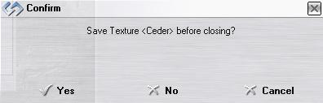

Step 26.

It’s now time to use the original stonework outline.

If you cannot remember which one that was, the image below
was my design:

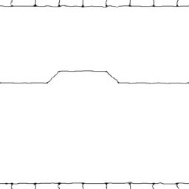

Step 26 - Continued.

Drag “Quick Texture Mixer” from the outline texture to the
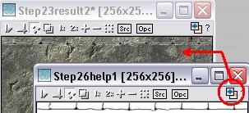
stonework texture:

Select “Emboss High” from
The pop-up menu:
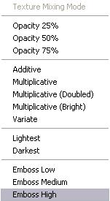

Drag “Quick Texture Mixer” again from
the outline to the stonework but select
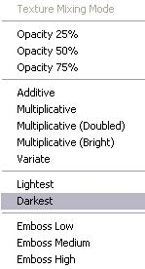
“Darkest” this time:

The result should resemble this image:
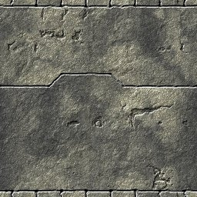

Step 27.

Make the stonework texture the active texture.

Click the “Texture Preview” button on the toolbar, it
resembles an eye:
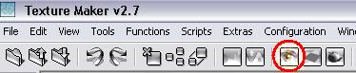

Click the “Plasma Overlay” button:
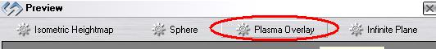

Next click on the “Expand” button:
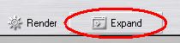

Click on the long grey button that appears along the left
Side of the texture preview window:
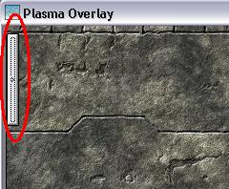

Set the width and height to
512 x 512:
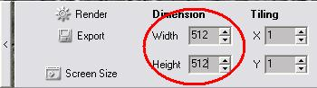

Click on the “Render” button until you have a result
that you approve of.

Step 27 - Continued.

Then click the button.

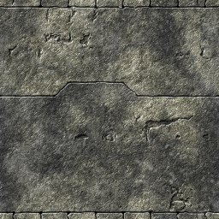

Here is my result:

Step 28.

Save the exported version to whatever you wish.

Step 29.

Now it’s time for the fun part – casting shadows to give it that extra bit of YES!!! The texture looks reasonable at this point but it is really flat. What it needs is a bit of shadow and shading to really make it stand out.

Make the outline texture active.

Expand the “Basic” group under “Function Selection” and
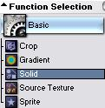
select “Solid”:

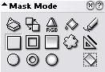

Set the “Mask Mode” to “Rectangle”:

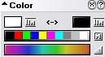
Step 29 - Continued.

Set the “Foreground” colour to white:

Blank out the areas of the texture you don’t need by
drawing a rectangle over them. For my design I’m going
to blank out the bricks at the top and bottom of the
design:
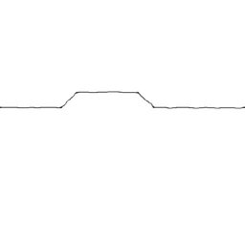

Step 30.

Expand the “Bump” group under “Function Selection” and
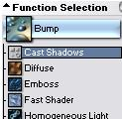
select “Cast Shadows”:

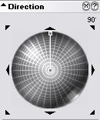

Set the “Direction Wheel” to 90DEG:

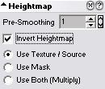

Under the “Heightmap” options
tick the “Invert” selector:

Step 30 - Continued.

Set the length of the shadows to what you wish by moving
the direction line away from the center of the wheel:
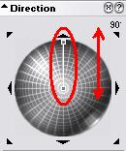
Set “OPC” on the stonework texture
and then apply the function to it.

Here is my result:

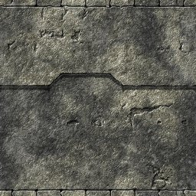

Save the texture.

Step 31.

Now lets add shadows to the brickwork in a different way.

Expand the “Basic” group under “Function Selection” and
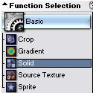
select “Solid”:

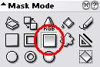

Set the “Mask Mode” to “Rectangle Gradient”:

Step 31 - Continued.

Set the “Variator Map” to “Brushed Metal” by clicking on
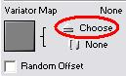
the “Choose” button:

Then select the texture from the list:
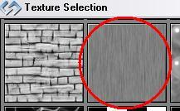

The “Variator Map” options are updated to show a thumbnail
of the selected texture and the textures name:
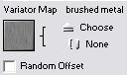

Set the direction of the gradient to up:
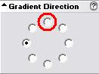

To do this you will need to click in the
radio button at the 12 O’clock position.

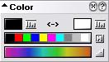

Set the “Foreground” colour to black:

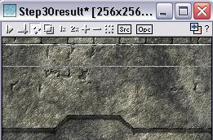

Now draw a rectangle beneath the
bricks at the top of the texture:

Once the mouse button is released
the rectangle effect is applied.

As can be seen on the next page.

Step 31 - Result.

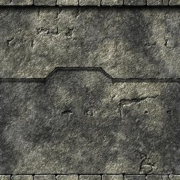

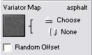
Step 32.

Change the “Variator Map” to “Asphalt”:

Draw the rectangle again but take it to about half the
height of the texture.

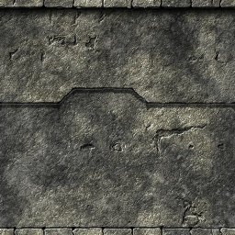

Step 33.

Change the direction of the gradient to down – 6 O’clock
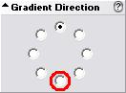
Position:

Draw the rectangle from just above the brickwork at the
bottom of the texture to about half way up.

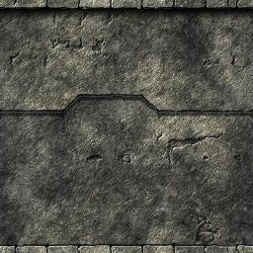

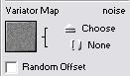
Step 34.

Change the “Variator Map” to “Noise”:

Draw a rectangle from the top of the brickwork at the
bottom of the texture to just a little above, this is
to add a little more depth:

The result can be seen at the top of the next page.

Step 34 - Result.

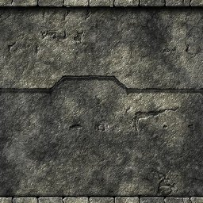

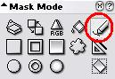
Step 35.

Change the “Mask Mode” to “Freehand Pen”:

Draw some dribble marks onto the texture, change the colour
a few times for extra effect. And here is the finished
product:

That concludes this tutorial.
_______________________________________________________________________

