Tutorial for Texture Maker 2.5 or above.

Note:- Texture Maker is a texture creation tool by Tobias Reichert.
For further product information please visit the official
site at http://www.texturemaker.com

All textures produced with Texture Maker.

Prerequisites: Texture Maker 2.5 or above.
Knowledge of the programs interface.

Steps: 34.
Difficulty: Intermediate.

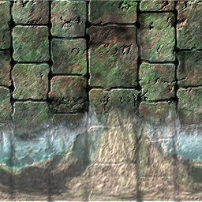
Creating Stone Brickwork And Adding A Mural.

Step 1.

Lets begin by creating a new texture by clicking on the new texture button on the TMAK toolbar(as shown in the image below).

The create texture dialogue box appears:

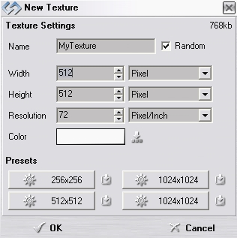
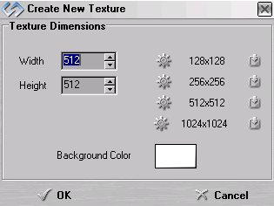

Note that there are two different images for the texture creation dialogue box as shown above. The lefthand image is for versions prior to 2.7 while the righthand image is for version 2.7 and above.

Set the "Background Color" to "White" and the "Texture Dimensions" to "Width & Height = 512".

In all these Texture Maker tutorials the creation size is 512x512. This is because it is easier to work at the larger resolutions. You can always resize the texture once you have completed it. If your screen size limits you from working at this size simply use the next one down, all these tutorials can just as easily be followed with a size of 256x256.

Once you are happy with the settings simply click the "OK" button to proceed.

Step 2.

Turn "Snap Surface" on which is located on the texture pane
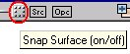
as can be seen in this example:

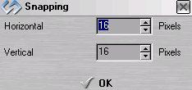
Leave the grid size at the
default of 16x16, if the
size is set at anything
else just change the values
to 16x16:

Step 3.

Under "Function Selection" Expand the
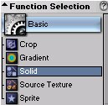
"Basic" group and select "Solid":

Set the foreground colour to black:
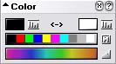

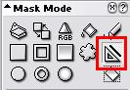
Next set the “Mask Mode” to “Line” tool:

Step 3 - Continued.

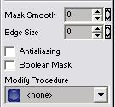
Also check that the following options are
not set to active under “Mask Mode”:

The tick box against
“Boolean Mask” needs to be Empty.

“Modify Procedure” needs to be set to “<none>”.

“Mask Smooth” and “Edge Size”
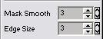
set to 3.

Tick the “Antialiasing” box:
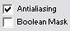

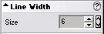
Lastly set the “Line Width” to “6”:

Also ensure that no “Variator Map” is set by clicking on the “none” button in the
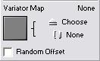
“Variator Map” portion on the menus:

Step 4.

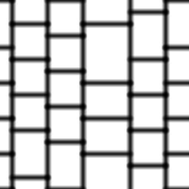
Draw out your brickwork
pattern, I’ve chosen a
simple design as shown here:

Step 5.

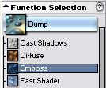
From “Function Selection” expand the “Bump” group and
select “Emboss”:

Reset the emboss function to it’s default by clicking on
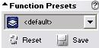
the “Reset” button under “Function Preset”:

The “Function Preset” should read
“<default>”.

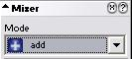
Set the “Mixer” to “Add” mode:

Step 5 - Continued.

Apply the function to the texture twice to obtain an effect similar to the one shown:
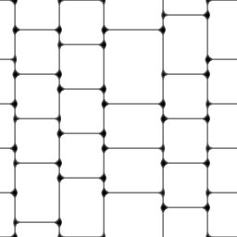

Step 6.
Turn “Snap Surface” off:

Step 7.

Under “Function Selection” expand the “Basic” group and
select “Solid”:

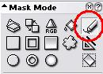

Select “Free Hand Pen” under “Mask Mode”:

Step 7 - Continued.
Set the brick pattern texture as the “SRC”:

Create another new texture exactly as shown in step 1.

On the newly created texture turn “Show source texture
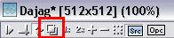
In background” on:

Now trace over the lines and allow yourself to drift slightly as the idea here is to make the lines less obvious.

Step 8.

From “Function Selection” expand the “Bump” group and
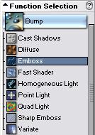
Select “Emboss”:

Set the “Mixer” to “Add” mode:

Apply the function to the texture – twice. The result should be something similar
To the example shown at the top of the next page.

Step 8 - Result.

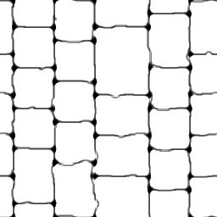

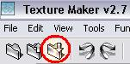
Step 9.

Save the texture created in step 8:

You can close without saving the original straight line
Texture if you have not already done so.
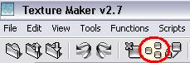

“Clone” the saved texture:

(The currently active texture is cloned).

Step 10.

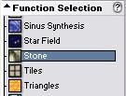
Expand the “Generator” group under “Function Selection” and
select “Stone”:

Click the “Reset” button beneath “Function Preset” to set
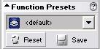
The function to it’s default:

Set “Mask Mode” to “Flood Fill” (Paint bucket icon):
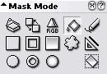

Find “Fill and Replace” on the scrolling menus and set the
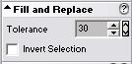
“Tolerance” to “30”:

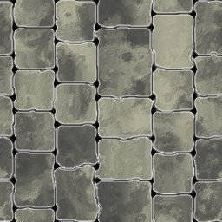
Fill the white areas of the texture until it resembles
something like this:

Step 11.

Using “Quick Texture Mixer” drag from the original texture
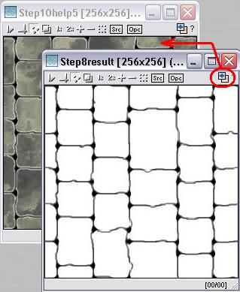
To the now cloned and filled in texture:

Then select “Emboss High”
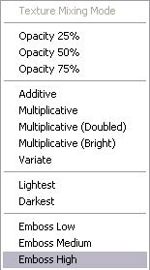
from the pop-up menu:

Step 11 - Continued.

Again using “Quick Texture Mixer” drag from the lines to
filled in texture. Only this time select “Darkest”:
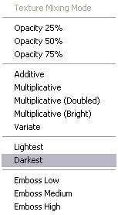

The resultant image should look
something like the one below.
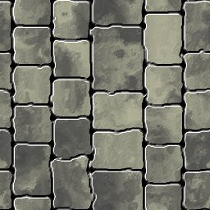

Step 12.

Create a new texture exactly as covered in Step 1.

Under “Function Selection” expand the “Generator”
group and select “Stone”:

Set the “Function Preset” to “Bumpmap” and apply to the new
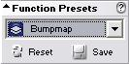
texture:

The result should be similar to the example at the top of
the next page.

Step 12 - Result.
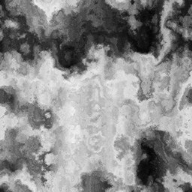

Step 13.

Drag “Quick Texture Mixer” from the bumpmap texture to the brickwork texture and select “Emboss High” from the pop-up menu:
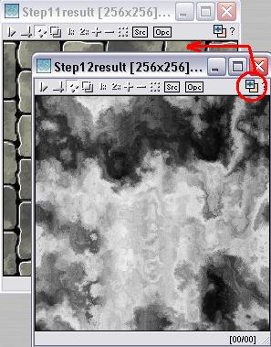

Step 13 - Result.

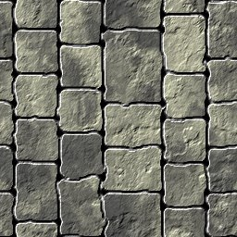

Step 14.

Wipe the bumpmap texture. You can do this in three ways.

Way 1. “Close” the texture and when prompted
to “Save” click the “No” button.

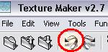
Way 2. Use the “Undo” feature:

Way 3. Wipe the texture with a single colour:
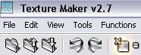

Once clicked you will need to select which
colour to wipe the texture with.

It’s up to you which one to use but in this example the
second way is the quickest as there is only one undo step.

Step 14 - Continued.

Change the “Function Preset” for the “Generator” – “Stone”
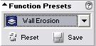
function to “Wall Erosion”:

Apply to the blank texture to obtain a result similar to
the one shown below:
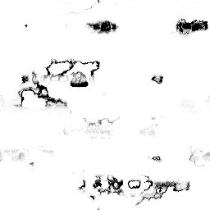

Step 15.

Drag “Quick Texture Mixer” from the erosion texture
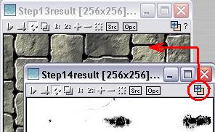
to the cloned texture:

Step 15 - Continued.

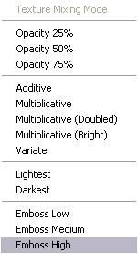
Select “Emboss High” from the pop-up
menu:

The resultant image should
resemble the one below:
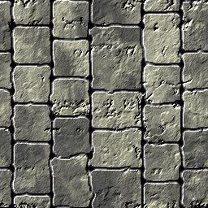

Step 16.

Wipe the erosion texture to a white background. If you
cannot remember how to do this please refer back to
step 14.

Providing you have not changed which function you have
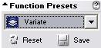
Selected change the “Function Preset”
to “Variate”:

If you did change the selected function you will need to
return to “Function Selection” and expand the “Generator”
group. Then select “Stone” before changing the “Function
Preset”.

Apply the “Variate” function the blank texture.

See the next page for an example of the expected result.

Step 16 - Result.



Step 17.

Drag “Quick Texture Mixer” from the variate texture to the
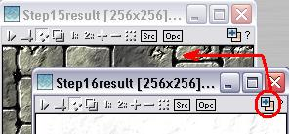
cloned texture:

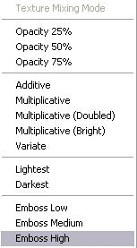

Select “Emboss High”
from the pop-up menu:

Step 17 - Result.

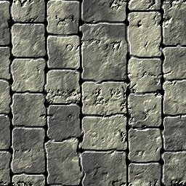

Step 18.

Wipe the variate texture back to white. Refer to step 14
If you cannot remember how to do this.

Step 19.
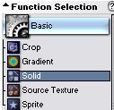
Under “Function Selection” expand the
“Basic” group:

Select “freehand Pen”
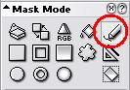
under “Mask Mode”:

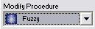
Set the “Modify Procedure” to “Fuzzy”:

And the “Foreground” colour to
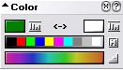
a dark green:

Draw randomly across the blank texture, example on next page.

Step 19 - Result.

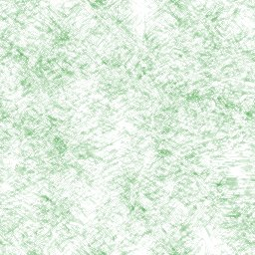

Step 20.

Change the “Foreground” colour to another shade of green,
and as in the last step draw random strokes.

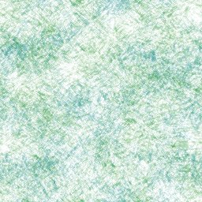

Step 21.

On the texture you’ve just drawn turn “OPC” on:
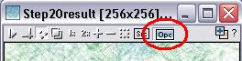

Step 22.

Change the shade of green again and as before draw randomly
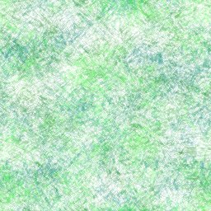
across the texture:

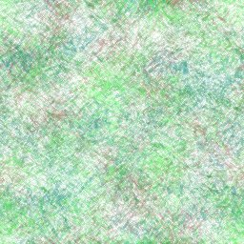
Step 23.

Change the colour to a dark
red this time before drawing
again in the texture:

Step 24.

For the last time change the colour to a lighter shade of
red and you’ve guessed it draw randomly across the texture.

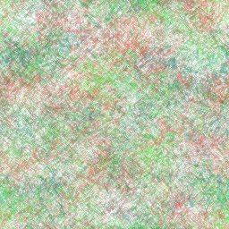

Step 25.
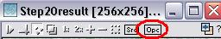
Turn “OPC” off:

Step 26.

Drag “Quick Texture Maker” from the red and green mess to
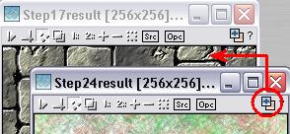
The brickwork texture:

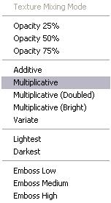
Step 26 - Continued.

Select “Multiplicative” from the
Pop-up menu:

The result should resemble
something like the image
below:
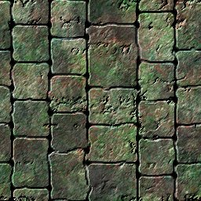

Step 27.

Close the green and red texture without saving.

The remaining steps of this tutorial cover the adding of a mural to the above texture that has been created using “FDE” that’s “First Day Engine” of Texture Maker. This tutorial does not include instructions on using the “First Day Engine”. The image has been pre-rendered.

Step 28.

Open the image you’re going to use as your mural and resize it to match the size of your brickwork texture.

This is the image I’m going to use for this tutorial:
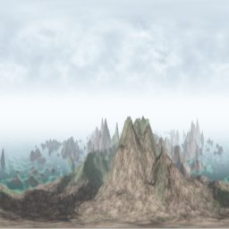

Once you have your image matching the dimensions of the brickwork texture close the original texture that you had to resize in order to conserve some resources.

Step 29.

Clone both the resized image that will become the mural and
the brickwork textures. To clone a texture first make sure
it is the active texture and then click the clone button on
the toolbar:
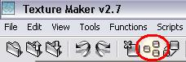

Minimize the clones once they are created.

Step 30.

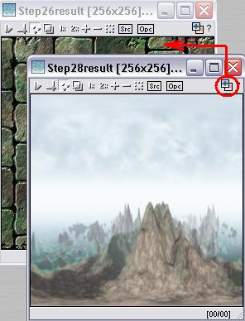
Using “Quick Texture Mixer” drag from the will be mural texture to the brickwork texture:

Select “Multiplicative” from
The pop-up menu:
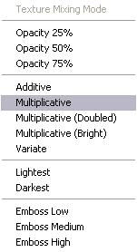

Repeat this procedure a second time.

Then use the “Quick Texture Mixer” a third time but pick
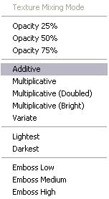
“Additive” from the pop-up menu this time:
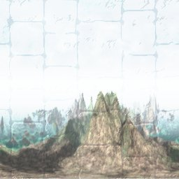

This is
The result:

Step 31.

Expand the “Basic” group from “Function Selection” and
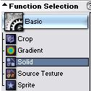
select “Solid”:

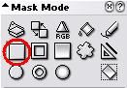

Set the “Mask Mode” to “Rectangle”:
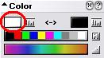

Set the “Foreground” colour
to white.

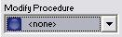
And set the “Modify Procedure” to none:

Draw the rectangle to cut away the upper portion of the
Texture, refer to the before and after images below:

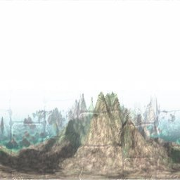
Before: After:

Then turn “SRC” on:
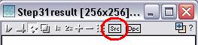

Step 32.

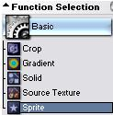
Remain in the “Basic” group but change to “Sprite”:

Set the “Trasparency” colour to
white and the “Tolerance” to 1
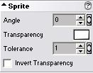
under the “Sprite” options:

“Restore-up” the cloned copy of the brickwork texture:

Turn “Snap Surface” on for the brickwork texture:
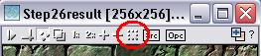

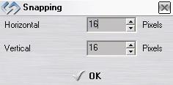
Leave the grid at the default
of 16x16:

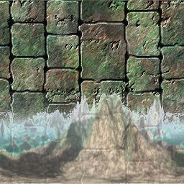

Click in the top lefthand corner of
the brickwork texture and drag all
the way down and across to the
bottom righthand corner, then
release the mouse button. The mural should then be rendered on the brickwork texture.

Step 33.

Drag “Quick Texture Mixer” from the texture created in step 31 to the brickwork texture and select “Emboss High” from the pop-up menu.

Step 34.

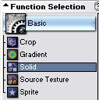
Re-select “Solid” from the “Basic” group:

Set the “Mask Mode” to
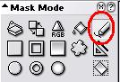
“Freehand Pen”:

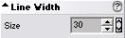
Set the “Line Width” to “30”:

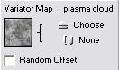

Select “Plasma Cloud” as the “Variator” map:

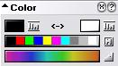
Set the “Foreground” colour to black:

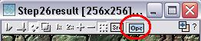
Activate “OPC” on the brickwork texture:

Trace over the upper and lower edges of the mural to mask
the contrasting white boundaries:

Take a look at the image on the next page for an example:

Step 34 - Result.

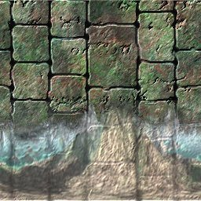

You could continue to trace over the edges of the brickwork
To give the bricks a little more depth:

That concludes this tutorial.
_______________________________________________________________________

