Tutorial for Texture Maker 2.5 or above.

Note:- Texture Maker is a texture creation tool by Tobias Reichert.
For further product information please visit the official
site at http://www.texturemaker.com

All textures produced with Texture Maker.
All screen shots taken from Ver 2.7 Beta.

Prerequisites: Texture Maker 2.5 or above.
Knowledge of the programs interface.

Steps: 13.
Difficulty: Intermediate.

Adding A Simple Decal.

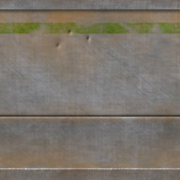

Step 1.

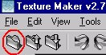
Lets begin by creating a new texture by clicking on the new texture button on the TMAK toolbar(as shown in the image below).

The create texture dialogue box appears:

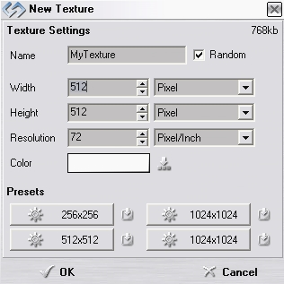
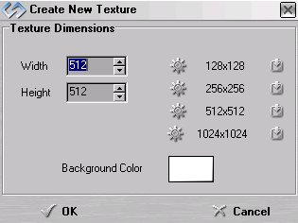

Note that there are two different images for the texture creation dialogue box as shown above. The lefthand image is for versions prior to 2.7 while the righthand image is for version 2.7 and above.

Set the "Background Color" to "White" and the "Texture Dimensions" to "Width & Height = 512".

In all these Texture Maker tutorials the creation size is 512x512. This is because it is easier to work at the larger resolutions. You can always resize the texture once you have completed it. If your screen size limits you from working at this size simply use the next one down, all these tutorials can just as easily be followed with a size of 256x256.

Once you are happy with the settings simply click the "OK" button to proceed.

Step 2.

Turn "Snap Surface" on which is located on the texture pane
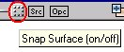
as can be seen in this example:

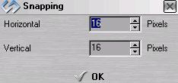
Leave the grid size at the
default of 16x16, if the
size is set at anything
else just change the values
to 16x16:

Step 3.

Under "Function Selection" Expand the
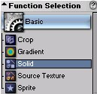
"Basic" group and select "Solid":

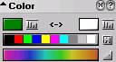
Set the background to your preferred colour, I'm using a dark green:

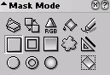
Step 4.

Set the "Mask Mode" to "Rectangle":

Step 5.
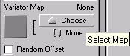
Under "Variator Map" click on the
"Choose" button:

Scroll down the list of maps and select "Plasma Cloud":
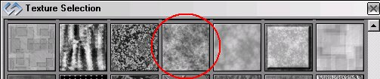

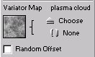
The "Variator Map" you select will then be shown as a thumbnail:

Step 6.

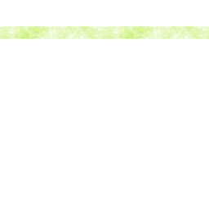
Draw a rectangle across the texture horizontally as shown in this example:

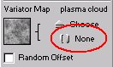
Step 7.

Clear the "Variator Map" by
clicking on the "None" button:

Step 8.
Turn "Snap Surface" off:

Step 9.

Change the "Mask Mode" to
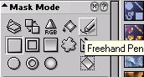
"Freehand Pen":

Step 10.

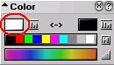
Change the "Foreground Colour" to "White":

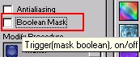
Also ensure that "Boolean Mask" is not selected by unticking the selection box:

Step 11.

Draw over the rectangle you drew previously and wipe out areas of it to give a better weathered/worn look:

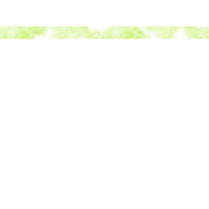

Step 12.

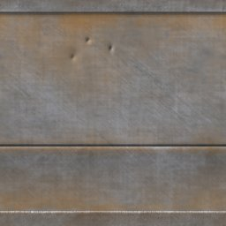
Open up the texture to which you want to add your decal. Mine is a simple metal wall texture:

Step 13.

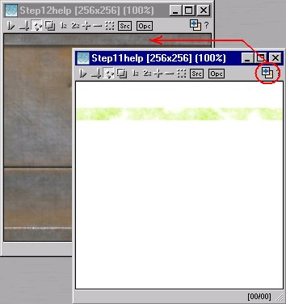
Drag from your decal texture to the your base using "Quick Texture Mixer":

Step 13 - Continued.

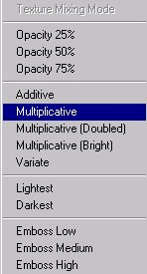
Select "Multiplicative" from the pop-up menu:

You may want to do this more than once
to get the shade you require, remember
that each time you use the "Multiplicative"
option the decal will become darker, use
it too many times and it will turn black.

That concludes this tutorial.
_______________________________________________________________________

