Tutorial for Texture Maker 2.5 or above.

Note:- Texture Maker is a texture creation tool by Tobias Reichert.
For further product information please visit the official
site at http://www.texturemaker.com

All textures produced with Texture Maker.

Prerequisites: Texture Maker 2.5 or above.
Knowledge of the programs interface.

Steps: 17.
Difficulty: Intermediate.

Creating A Rivit Or Screwhead.

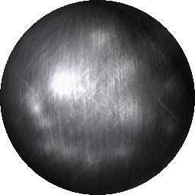

Step 1.

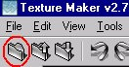
Lets begin by creating a new texture by clicking on the new texture button on the TMAK toolbar(as shown in the image below).

The create texture dialogue box appears:

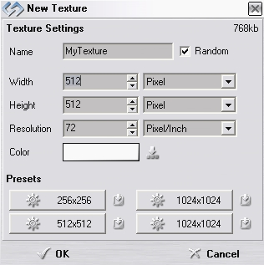
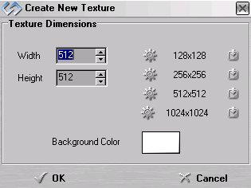

Note that there are two different images for the texture creation dialogue box as shown above. The lefthand image is for versions prior to 2.7 while the righthand image is for version 2.7 and above.

Set the "Background Color" to "White" and the "Texture Dimensions" to "Width & Height = 512".

In all these Texture Maker tutorials the creation size is 512x512. This is because it is easier to work at the larger resolutions. You can always resize the texture once you have completed it. If your screen size limits you from working at this size simply use the next one down, all these tutorials can just as easily be followed with a size of 256x256.

Once you are happy with the settings simply click the "OK" button to proceed.

Step 2.

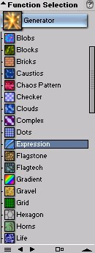
Under "Function Selection" expand the
"Generator" group and select "expression":

Then set the "Function Preset"
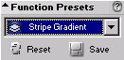
to:

The result once you apply it to the
Texture should resemble the next
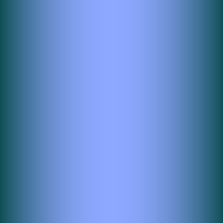
Image:

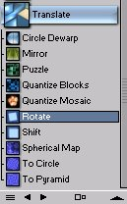
Step 3.

Expand the group "Translate" under
"Function Selection" and select "Rotate":

Set the direction of rotation to 45DEG
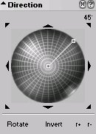
via the "Direction Wheel":

Apply to the texture to get a result something like the next image:
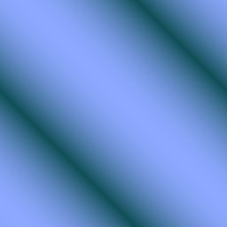

Step 4.

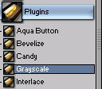
From the "Function Selection" expand the
"Plugins" group and select "Grey Scale":

The result is fairly unspectacular but just what we need:
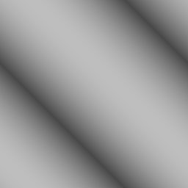

Step 5.

Create a new texture as was described in Step 1.

Keep the same size and attributes.

Step 6.

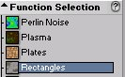
From the "Function Selection" expand the
"Generator" group and select "Rectangles":

Apply the function to the new texture created in Step 5:
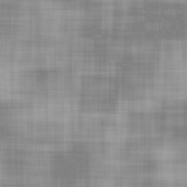

Step 7.

Use "Quick Texture Mixer" and drag from the "Rectangles" texture to the "Expressions" texture.
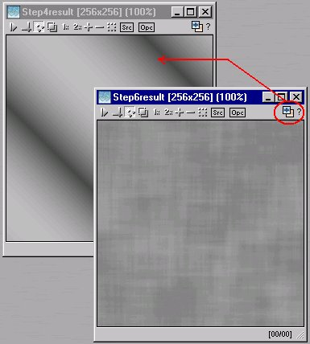

Select "Multiplicative"
from from the pop-up menu:
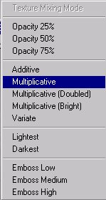

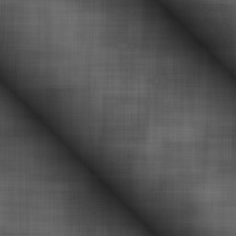
The result will be a mixture
of the two textures:

Step 8.

On the "Expressions" texture turn
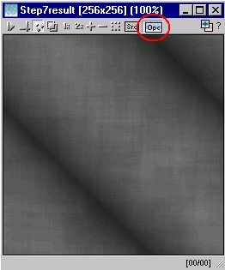
"OPC" to on:

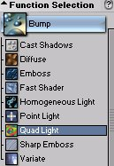
Under "Function Selection" expand the
"Bump" group and select "Quad Light":

The result will be a slight change to
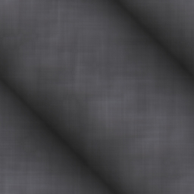
The colours:

Basically you have now completed the base metal texture for the rivit.

Step 9.

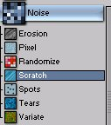
Expand the group "Noise" under
"Function Selection" and select "Scratch":

The direction of the scratches also
needs to be set to 90DEGs. Just as
with the "Rotation" function used
earlier the direction is controlled
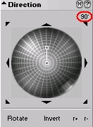
by the "Direction Wheel":

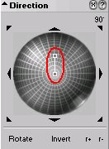

On the "Direction Wheel" there is Also a
way to set the length of the "Scratches",
set the length to about half the wheel:

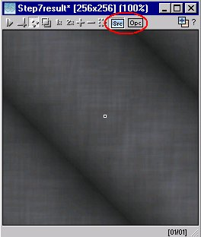
Next turn "OPC" off on the "Expressions" texture and turn "SRC" on:

Step 9 - Continued.

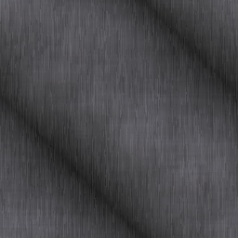
Apply the function to the
Texture to obtain a result
something like this:

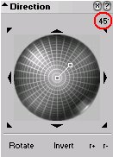
Using the "Direction Wheel" change the angle of the "Scratches to 45DEG:

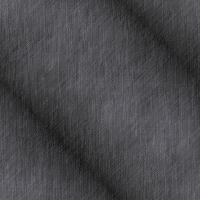
Apply the function to the whole texture for a result like this image:

Step 10.

Create another new texture as described in Step 1. Again retain the size and colours as previously used to create the other textures in this tutorial.

Step 11.

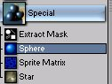
Expand the "Special" group under
"Function Selection" and select "Sphere":

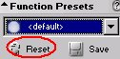
As we need only the default settings for this function set the "Function Preset" to default. If "Function Preset" is already set to default you need do nothing, otherwise simply click the "Reset" button:

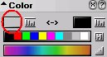
Set the foreground colour to a light grey:

Step 12.

Turn "Snap Surface" on at a grid size of 16x16:
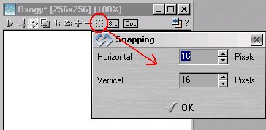

Simply click the "OK" button to set the grid size at the values shown. If the grid is set to a size other than 16x16, just amend the values before clicking "OK".

Step 13.

Draw your "Sphere" on the newly created texture from top corner to bottom. It makes no difference if you draw bottom to top, or top to bottom, just draw the "Sphere" as large as you can on the texture:
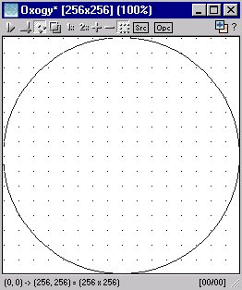

Step 13 - Continued.

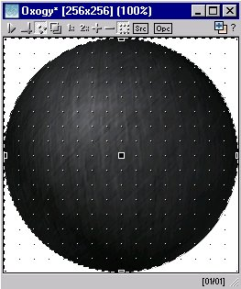
When you have drawn your
"Sphere" release the
mouse button to actually
render the "Sphere":

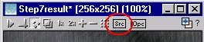
For the last item in this step turn "SRC" off on the "Expressions" texture:

Step 14.

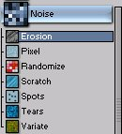
Expand the "Noise" group beneath
"Function Selection" and select
"Erosion":

Set the "Function Preset"
to "Spider Web":
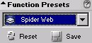

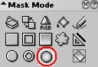
Change the "Mask Mode" to "Gradient Circle":

Draw a circle to cover all of the "Sphere" drawn in step 13. This should be the result:
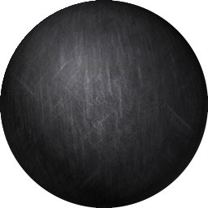

Step 15.

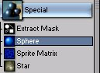
Open the "Specials" group under "Function Selection" and choose "Sphere":

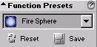
Set the "Function Preset" to "Fire Sphere":

Change the foreground colour
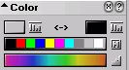
to a light gray:

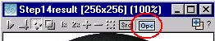
Turn "OPC" on for the
"Sphere" texture:

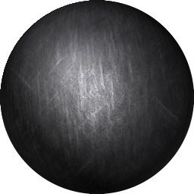
Draw the new "Sphere" so that it covers all of the previously drawn "Sphere" to get a result like the one shown:

Step 16.

Carry out the same procedure as in Step 15, but this time use smaller spheres to lighten us the darker areas:
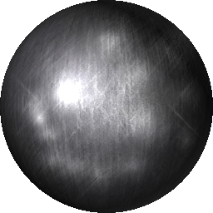

Step 17.

To breakup the light a little you can set the the textures "OPC" on and apply scratches again as in step 10. This is down to personal taste, simply apply additional effects as you need or see fit.

That concludes this tutorial.
_______________________________________________________________________

