Tutorial for Texture Maker 2.7 or above.

Note:- Texture Maker is a texture creation tool by Tobias Reichert.
For further product information please visit the official
site at http://www.texturemaker.com

All textures produced with Texture Maker.

Prerequisites: Texture Maker 2.7 or above.
Knowledge of the programs interface.

Steps: 16.
Difficulty: Intermediate.

Using Sprite Matrix.

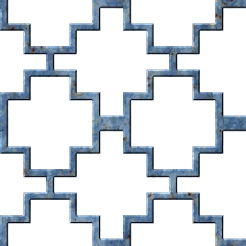

Step 1.

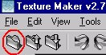
Lets begin by creating a new texture by clicking on the new texture button on the TMAK toolbar(as shown in the image below).

The create texture dialogue box appears:

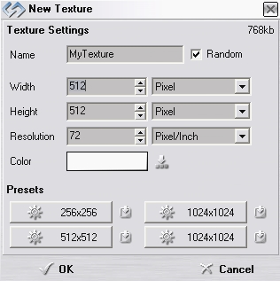
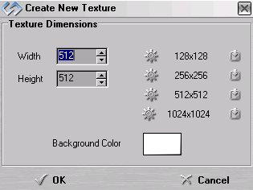

Note that there are two different images for the texture creation dialogue box as shown above. The lefthand image is for versions prior to 2.7 while the righthand image is for version 2.7 and above.

Set the "Background Color" to "White" and the "Texture Dimensions" to "Width & Height = 512".

In all these Texture Maker tutorials the creation size is 512x512. This is because it is easier to work at the larger resolutions. You can always resize the texture once you have completed it. If your screen size limits you from working at this size simply use the next one down, all these tutorials can just as easily be followed with a size of 256x256.

Once you are happy with the settings simply click the "OK" button to proceed.

Step 2.

Create another new texture as shown in Step 1 but with a
black background.

Step 3.

Set the texture you just created in Step 2 as “SRC”:
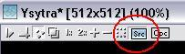

Step 4.

Under “Function Selection” expand the “Special” group and
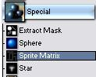
select “Sprite Matrix”:

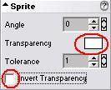
Step 5.

Set the “Sprite” options as shown here →

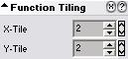
Step 6.

Set the “Function Tiling” as shown →

If you want the pattern to tile more increase the X-Y values. Smaller values make the pattern tile less.

Step 7.

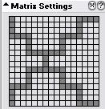
Draw your design on the “Matrix Settings” grid, you can see mine here →

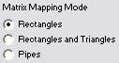

← Set the style to one of three
“Matrix Mapping Modes”.

Apply your design to the texture created in Step 1.

As there are three styles here is the pattern shown above
in each of the three styles so you can see the difference.

This tutorial uses the “Rectangles” option.

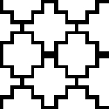
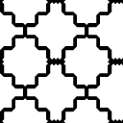
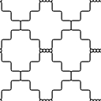

Rectangles Rectangles & Pipes
Triangles

Step 8.

Clone the texture just modified in Step 7.
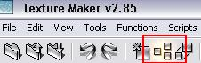

Step 9.

Under “Function Selection” expand the “Color” group and
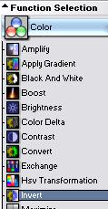
select “Invert”:

Apply to the clone created in Step 8.

Step 10.

Expand the group “Filter” under “Function Selection”
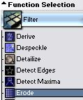
and select “Erode”:

Step 11.

Click the “Reset” button under “Function Preset”:
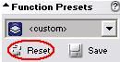

Apply the function twice.

Step 11 - Result.
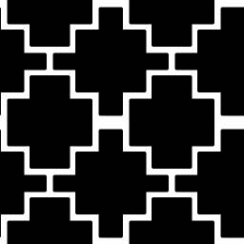

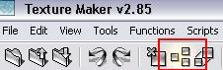
Step 12.

Clone the texture created in Step 7:

Step 13.

Open or create a texture that will form the material for the matrix pattern, below is the one used in this tutorial:
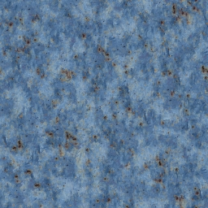

Step 14.

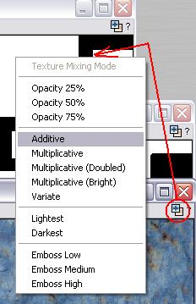
Drag “Quick Texture Mixer” from the “Material” texture(Step 13) to clone created in Step 12.

Select “Additive” from the pop-up
menu.

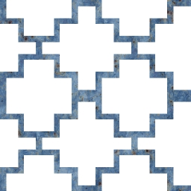

← Here is the result.

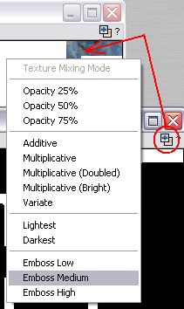
Step 15.

Drag “Quick Texture Mixer” from
the “Inverted” texture(Step 9) to
texture modified in Step 14.

Select “Emboss Medium” from the
pop-up menu.

Step 15 - Result.

Step 16.

This is not a mandatory step and need only be followed if
you require a mask which can be loaded as an alpha channel.

Use the Undo button on the “inverted” texture to remove the two “Erode” functions.

“Save” the “inverted” texture – this can then be loaded as the alpha channel.

That concludes this tutorial.
_______________________________________________________________________

