Tutorial for Texture Maker 2.7 or above.

Note:- Texture Maker is a texture creation tool by Tobias Reichert.
For further product information please visit the official
site at http://www.texturemaker.com

All textures produced with Texture Maker.

Prerequisites: Texture Maker 2.7 or above.
A good working knowledge of the interface.

Steps: 30.
Difficulty: Advanced.

Creating A Stone Rune.

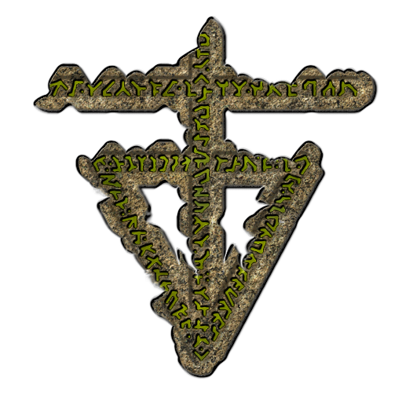

Step 1.

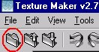
Lets begin by creating a new texture by clicking on the new texture button on the TMAK toolbar(as shown in the image below).

The create texture dialogue box appears:

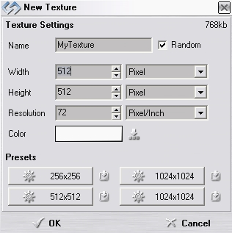

Set the "Background Color" to "White" and the "Texture Dimensions" to "Width & Height = 512".

In all these Texture Maker tutorials the creation size is 512x512. This is because it is easier to work at the larger resolutions. You can always resize the texture once you have completed it.

Once you are happy with the settings simply click the "OK" button to proceed.

Step 2.

On the newly created texture turn “Snap Surface” ON:
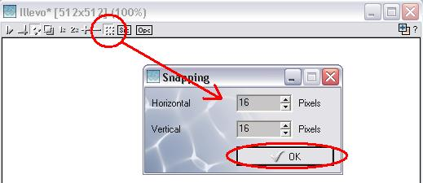

Leave it set at the default of 16x16.

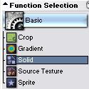
Step 3.

Under “Function Selection” expand the
“Basic” group and select ”Solid”.

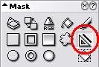

Set the “Mask” to line.

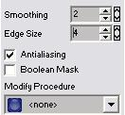

Also set “Mask smoothing” = 2
“Edge Size” = 4
Tick “Antialiasing” if it is not already.
The “Modify Procedure” should be “None”.

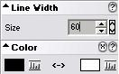

The “Line Width” also needs to be set to 60,
And the “Color” to black.

Step 4.

Draw out the body of your design, here is the design for

this tutorial:

Save the design as “RuneMask”.

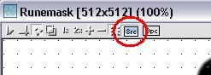
Step 5.

Set “RuneMask” as “SRC”:

Create a new texture as in Step 1.

Turn “Snap Surface” ON:
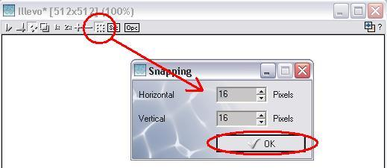

Leave it at the default of 16x16.
Step 5 - Continued.
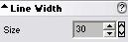
Set the “line size” = 30:

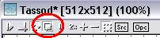
Turn “Show Source Texture in Background”
ON.

Step 6.

Draw the design again with the thinner line and keep it
within the lines of the original as shown:
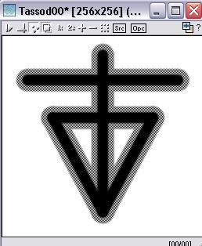

Save the texture as “RuneMask2”:

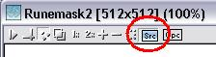
Set “RuneMask2” as “SRC”:

Step 7.

Create a new texture as in Step 1.

Step 8.

Turn “Snap Surface” ON on the newly created texture.

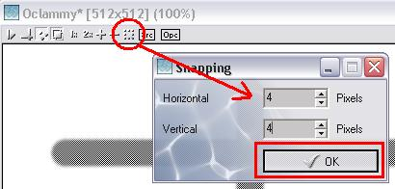

Set the size to 4x4.
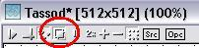
Turn “Show Source Texture in Background”
ON:

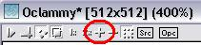
Zoom in twice:

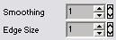
Change “Mask smoothing” = 1
and “Edge Size” = 1

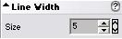
“Line Width” = 5

Step 9.

Draw a pattern or some design within the constraints of
“RuneMask2”. As shown in the background of the new texture.
Don’t go beyond the edges in fact try to keep a gap between
The edges of the pattern and the edges of “RuneMask2”, see
The example below:
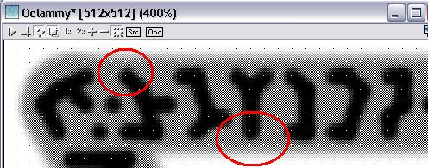

Save the texture as “RuneMaskText”.

Here is the version I’m using for this tutorial:
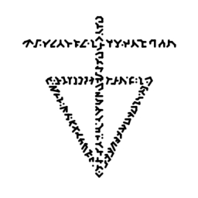

Step 10.

Clone the first texture named “RuneMask”:

Step 11.

Turn “SRC” OFF on the texture named “RuneMask2”.

Step 12.

From “Function Selection” expand the “Distortion” group
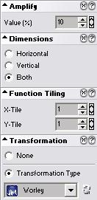
and select “Displace”.

Set “Amplify” = 10

“Dimensions” = “Both”

“Function Tiling”
“X-Tile” = 1
“Y-Tile” = 1

“Transform Type”
= “Worley”.

Apply the distortion function to “RuneMask”.

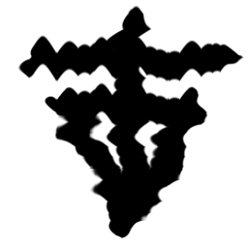

The result can be seen
in this example:

Step 13.

Drag “Quick Texture Mixer” from “RuneMask” to clone created
in Step 10. Select “Additive” from the pop-up menu.
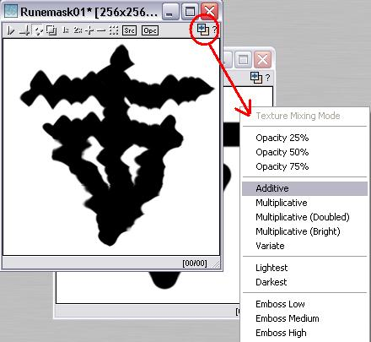

Save the texture as “Runemaskruin”.

Step 14.

Undo the “Distortion” effect on “RuneMask”.

“RuneMask” should now be back in its original state:

See image at top of next page to confirm.

Step 14 - Result.

Step 15.

Now that all the masks have been created we need two textures to form the base materials. One as the stone for the body and another for the metal of the pattern.

This tutorial uses some “ISampled” photographs. Which you can see below:

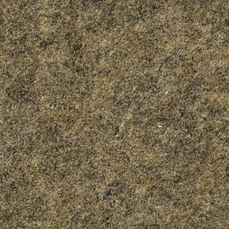

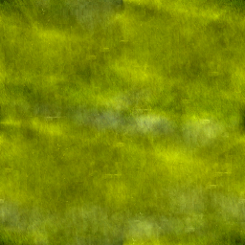

They will be referred to as “Stonebase” and “Basemetal” for the duration of the tutorial.
Step 16.

Clone “RuneMask”.

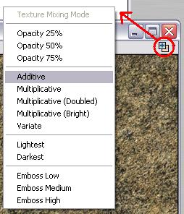

Drag “Quick Texture Mixer”
from “Stonebase” to the
clone just created.

Select “Additive” from the
pop-up menu.

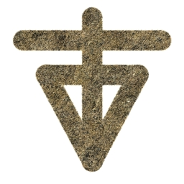

This is the result.

Close “Stonebase” it is no longer required.

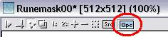
Step 17.

Set “OPC” on the result of Step 16.

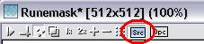
Set “RuneMask” as “SRC”.

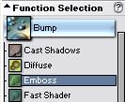
Step 18.

From “Function Selection” expand the “Bump”
group and select “Emboss”:

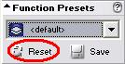

Click the “Reset” button under “Function Preset”
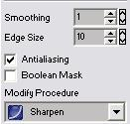

Set “Mask Smoothing” = 1
“Edge Size” = 10

Tick “Antialiasing”

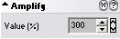

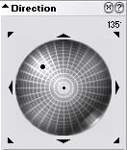
Set “Amplify” to 300.

Set the direction wheel as shown here:

Adjust the “Heightmap” settings to the following:
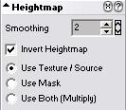

“Smoothing” =2

Tick “Invert Heightmap”

Select “Use Texture/Source”.

Apply to the result of Step 16.

See top of next page for the result.

Step 18 - Result.
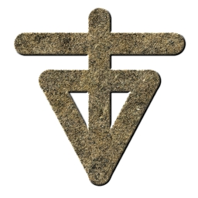

Step 19.

From “Bump” section under “Function Selection” select
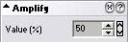
“Cast Shadows”.

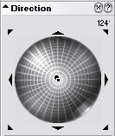
Set “Amplify” = 50.

Set the “Direction” wheel as seen in the example.

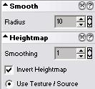

Adjust “Radius” = 10

Set “Heightmap” settings:

“Smoothing” = 1
Tick “Invert Heightmap”
Select “Use Texture/Source”

Apply to the result of Step 16.

Result can be seen at the top of next page.

Step 19 - Result.
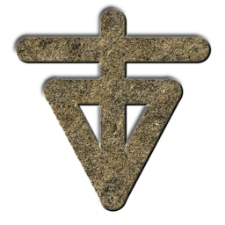

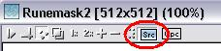
Step 20.

Set “SRC” on “RuneMask2”.
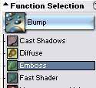

Select function “Emboss” from “Function Selection” under “Bump” group.

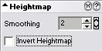

Untick “Invert Heightmap” under “Heightmap” settings:

Apply function to the result of Step 16.

Result can be seen at top of next page.

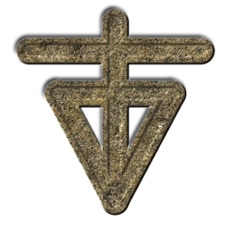
Step 20 - Result.

Step 21.

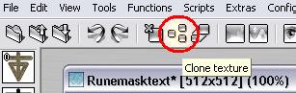
Clone “RuneMaskText”.

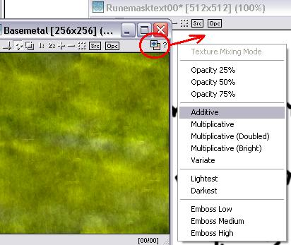

Drag “Quick Texture
Mixer” from “Basemetal”
to the clone you just
Created and select
“Additive” from The
pop-up menu.

Close “Basemetal” it is no longer required.

Result can be seen at top of next page.

Step 21 - Result.
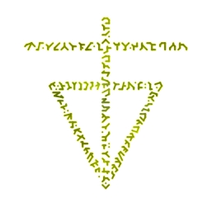

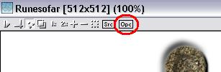
Step 22.

Turn “OPC” OFF on the
result of Step 16.

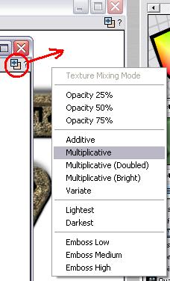

Drag “QTM” from “RuneMaskText” to
the result of Step 16 and Select
“Multiplicative” from the pop-up menu.

Result at top of next page.

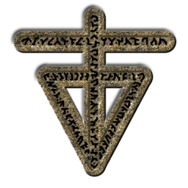
Step 22 - Result.

Step 23.

Zoom In on the texture shown in the above example.
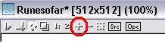
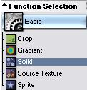

Under “Function Selection” expand the “Basic”
group and select “Solid”.

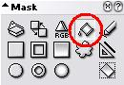

Select “Flood Fill” tool under “Mask”.

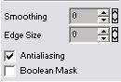
Adjust “Mask” settings:

“Smoothing” = 0
“Edge Size” = 0

“Antialiasing” = ON

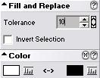
“Fill and Replace” settings need to be:
“Tolerance” = 10
“Invert Selection” = OFF.

“Color” = White.

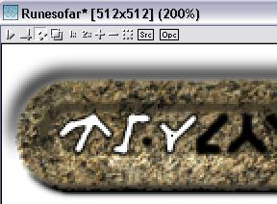
Step 23 - Continued.

Fill in the black pattern as
in the example here:

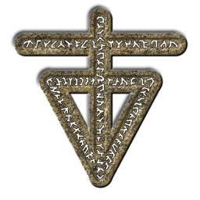

← And the finished result.

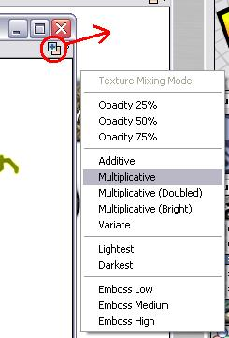

Step 24.

Drag “Quick Texture Mixer” from Step 21’s
result to Step 23’s result and select
“Multiplicative” from the pop-up menu.

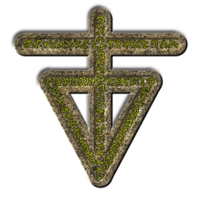

← This is the result.

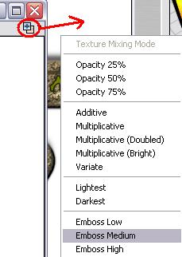
Step 25.

Drag “Quick Texture Mixer” from
“RuneMasktext” to the Result of
Step 24 and select “Emboss Medium”
from the Pop-up menu.

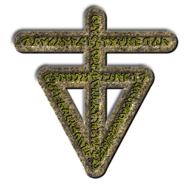

← Here is the result.

Close the texture result from Step 21.

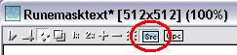
Step 26.

Set “SRC” on “RuneMasktext”.
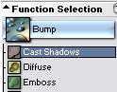

Select “Cast Shadow” from “Function Selection” under
group “Bump”.

Step 26 - Continued.
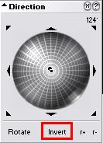

As changed the options relating to this function
earlier this tutorial assumes they have not been
altered since. If you have changed them or are
unsure set them as shown in Step 19.

If you have not changed them you need only click on
“Invert” button beneath the “Direction” wheel.

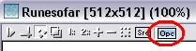

Set “OPC” on the result of Step 25.

Apply the function to the result of Step 25.

Close “RuneMasktext” we have no further use of it.

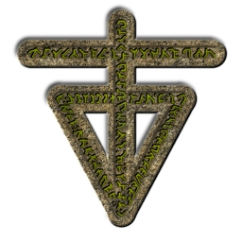

Step 27.

Clone “Runemaskruin”.
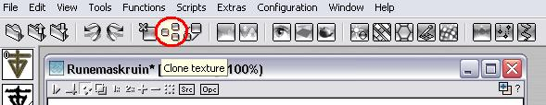

Step 27 - Continued.

Drag “Quick Texture Mixer” from the result of Step 26 to
The clone you just created and select “Additive” from the
pop-up menu.
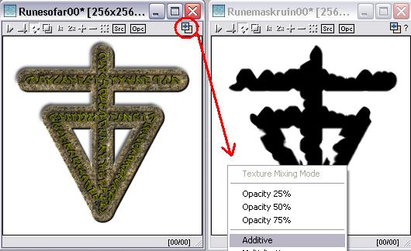

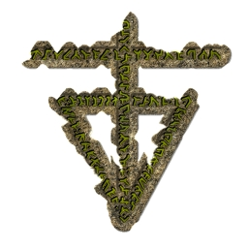

And here is the result →

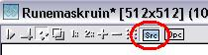
Step 28.

Set “SRC” on “Runemaskruin”.

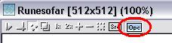

Set “OPC” on the result of Step 27.

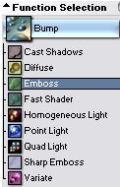
Step 29.

Expand the group “Bump” under
“Function Selection” and select
“Emboss”.

Apply function to the result of Step 27.

Step 30.

Click “Invert” under the “Direction” wheel and apply to the
result of Step 29.
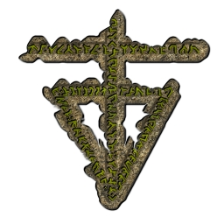

That concludes this tutorial.
_______________________________________________________________________

