Tutorial for Texture Maker 2.8 or above.

Note:- Texture Maker is a texture creation tool by Tobias Reichert.
For further product information please visit the official
site at http://www.texturemaker.com

All textures produced with Texture Maker.

Prerequisites: Texture Maker 2.8 or above.
This tutorial presumes you have no working
knowledge of the program.

Steps: Not Applicable.
Difficulty: Beginner.

Beginners Overview – Menu Bar.

Introduction.

If you have never used Texture Maker before then this is a good place to start. The Beginners Overview tutorials assume you have never used Texture Maker before and are not familiar with the interface.

Texture Maker is a powerful tool and with minimal effort it is possible to create some amazing results. What this set of tutorials is aiming to do is give the beginner a better understanding of the applications interface and does not cover the creation of actual textures. Although there will be examples dotted though out the tutorials. There are plenty of tutorials located at http://www.texturemaker.com covering the actual creation of textures. You can also look at my site http://www.relmoftyrants.co.uk for further tutorials.

Most of all I advise to experiment with the application and not be afraid to try something you may well surprise yourself. Then when you have your master piece, write a quick tutorial and show us all how its done.

Many of the items on the menu bar can also be accessed via the tool bar and or the function bars. However I'm not going to point out which ones. What this tutorial will cover is each of the options on the menu bar one at a time. This means that some later areas of the overview tutorials will appear to be the same as some things already covered.

Where to start.

As the best place to start is funnily enough the beginning I’m going to start with the menu bar which is located below the applications title bar.

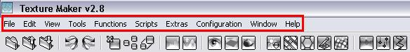

The image above has the menu bar surrounded by a red box to help you locate it within the application.

So lets begin with the “File” menu option.

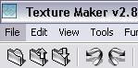
When you place the mouse pointer on an item of the file menu the background color of the item changes to let you know what item you will activate when you click a mouse button:

Click the left mouse button when the “File” item is highlighted.
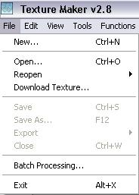

The “File” menu appears as
Shown in the example to the
Right of this text:

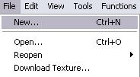

Move the mouse pointer to the first option
“New” and then click the left mouse button.

Your first question at this point may well be “What does that mean?” Thankfully the answer is simple. “New” = Create a blank texture. Left clicking on this item displays the “Create Texture” dialogue box, which can be seen at the top of the next page.

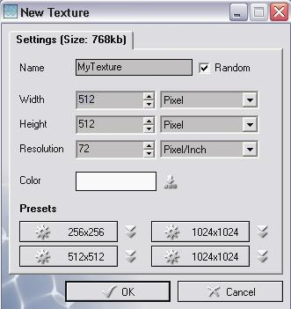

The “New Texture” dialogue box is basically asking you three things.

- What would you like your texture to be called?
- What size do you what the texture to be?
- What background color should the texture have?

Lets take a closer look at the options:

- What would you like your texture to be called?


If you want to name your texture simply replace the text “MyTexture” with whatever you please. If your not sure leave it as it is. You can also see a tick next to the “Random” option, this instructs the application to create a random name for the texture.

- What size do you want the texture to be?
You can set the width and height of the texture simply by typing in a new value. The options at the side of the width and height entry fields allow you to choose which measurement to use.(Pixel/Inches/CM)

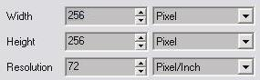

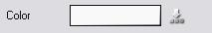
- What background color should the texture have?

The white box in the example above shows the currently selected color of the background.

To change this simply click on the white area or the symbol next to it to bring up the color
selection dialogue box.

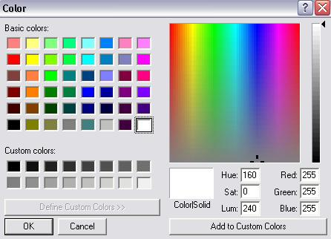

Now lets take a closer look at the color selection box:
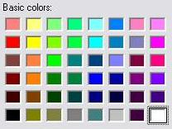
To choose a color simply click on one of the colors shown in the table and then click the “OK” button to make that your textures background color.

The white box in the table has a dotted rectangle surrounding it this is showing you the currently selected color.
1). Basic colors:

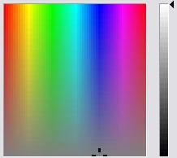
2). Color selection chart:
As with the basic colors shown in the previous example to choose a color here simply point your mouse at a color and left click.

The grey scale slider to the left of the picker area allows you to modify the shade of the selected color.

Once you have the color you require simply click the “OK” button.

3). Custom colors:
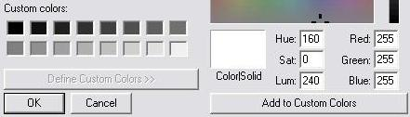

In order to help you locate a color you’ve used before you can set it as a
custom color. First select one of the custom color boxes and then select
the color you wish just as you did in the previous steps. If you know the
values of the color you need you can just type them in. Red, Green, Blue,
Hue, Sat(saturation”, Lum(luminosity). Lastly click on the “Add to Custom
Colors”. The selected custom color box will update with your chosen color.

Once you have selected your color and clicked the “OK” button you will be returned to the
texture creation dialogue box.

The color box will now display your selected color:

There is just one more thing of note on the create texture dialogue box, the presets:
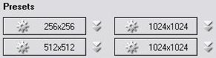

This series of buttons allows you to set the width and height of the texture at a single click of a button.
You can set your own presets by clicking on the symbol to the right of each button.

If at anytime you decide you no longer wish to create a texture click the “Cancel” button.

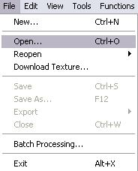
File Menu - Open.

Move the mouse pointer to the second option
“Open” and then click the left mouse button.

As with the “New” option the meaning is fairly obvious but still needs to be clarified. “Open” is retrieve already created image/texture. This can be from any storage device recognized and currently plugged into your PC.

Once you have clicked on the “Open” option the open dialogue box appears on screen, an example of it is shown below.

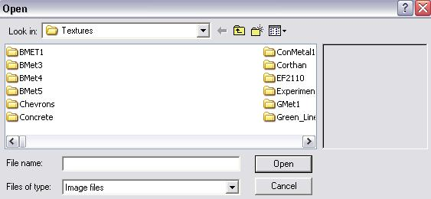

Basically the dialogue box is asking, “Exactly what do you want to open?”

Lets take a closer look at the various parts of the dialogue box.

The white box with the downwards facing arrow in the right-hand corner allows you to quickly navigate the data structure of your hard disks and other storage mediums. The text it currently displays is your current position.
The first icon an arrow pointing to the left is currently unavailable. It’s unavailable as we have not moved to another area on our storage medium. The arrow allows you to quickly return to a previous location you visited. As we have only visited this one location there are no previous ones for us to move too.
The second icon move up one level of the data structure with each press.
The third icon creates a new folder at your current level in the data structure.

The forth icon allows you to change how the contents pane displays the files. Try a few of the options to see how it works.
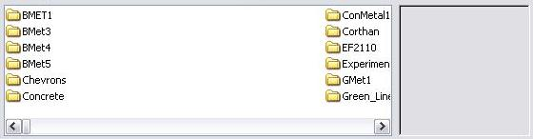

The example above is the contents pane showing the items in your current location on the data structure. The gray box at the right-hand edge is the preview pane but will only display something if you click on an image file. As you can see in the next image.
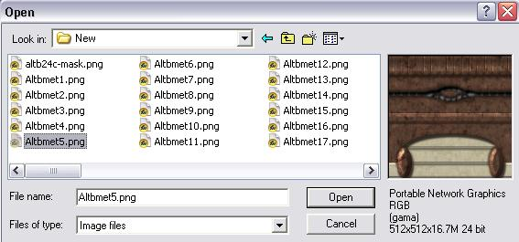

Also note that a selected file is highlighted and its name placed in the "File name:" box towards the bottom of the window. To select a file you simply click on it in the contents pane. If you double-click a file it will open. A single-click merely selects the file and you have to click the Open button to actually open it.
The Cancel button aborts the open operation as does the `x` button in the top right of the window.
You can also delete and rename as well as move files in this area but, I'm not going to cover that in this tutorial.

Tutorial continues on next page.

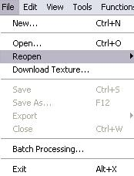
File Menu - Reopen.

The Third option on the file menu is Reopen
this option lets you open previously opened
texture of many different image types.

The black arrow at the end of the option indicates that there is another menu. This addition menu will open after a short pause or when you click.

The additional menu gives a list of the last 8 textures that you have opened. As in this example:
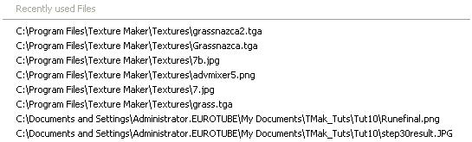

If this is the first time you’ve used Texture Maker it is possible there will be no entries under the heading “Recently used Files”.

Providing you have at least one on the list try selecting one:
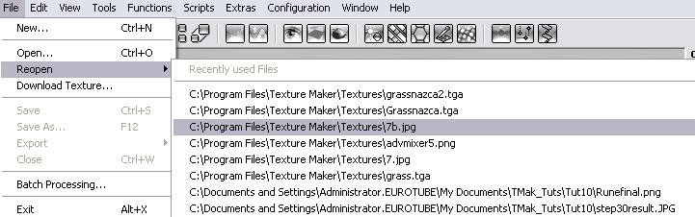

Moving the mouse pointer over an option highlights it, you must left click on an item to actually reopen it.

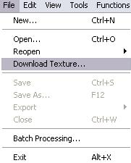
File Menu – Download Texture.

The forth option on the “File” menu
is “Download Texture”.

Once selected the following dialogue box appears on screen:
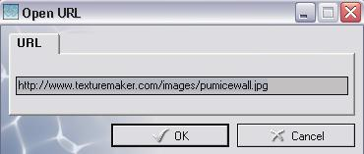

The “URL” request is basically asking you for an internet address of an image that can be downloaded. The example above shows one on Texture Makers home site.

A URL always looks something like the one shown in the example. Here is another example and not a real address http://www.somepic.com/atsomeplace/apic.jpg.

Here are some real addresses from my site for you to try:

http://www.relmoftyrants.co.uk/s/at1.jpg
http://www.relmoftyrants.co.uk/s/floor1.jpg

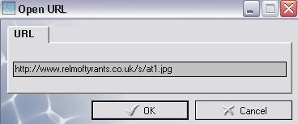
Using one of the ones above or any address you know is OK to use, try to download one.

Enter the URL as in this
Example and then click
The “OK” button.

The URL requester changes to show you the status of the download:
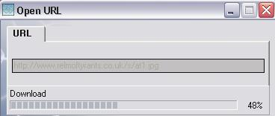

Once the status bar reaches 100% the “Open URL” box will automatically close and the downloaded texture is displayed.

If you used the same one as me in this tutorial this is the texture you will see, it was created entirely within Texture Maker.

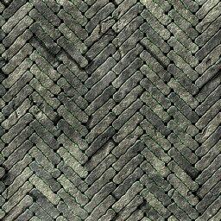

Tutorial continues on next page.

File Menu – Save.

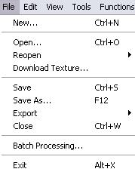
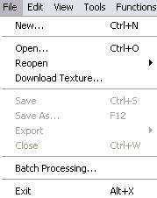
The fifth option on the menu can appear in one of two states as shown below:

You may also note that it is not alone in this condition. Any option that appears in gray is currently unavailable. This is not always because you’ve made a mistake or the computer is about to crash. It’s just a way of the program letting you know these options are currently of no use.

In the case of “Save”, you can only save a texture if you have one currently loaded in the program. Either through “New”, “Open”, “Reopen”, or “Download Texture”, obviously it’s impossible to save something you don’t have.

Just as with all the options highlight “Save” and then click the left mouse button to activate it. Again you can only try this if you have a texture to save, of if the option is gray first open one and then try.

If you save an opened texture, in other words load a previously created texture, when you click save the box shown at the top of the next page does not appear, the texture is just saved and overwrites the older version.

Tutorial continues on next page.

Providing you can “Save” this box appears:
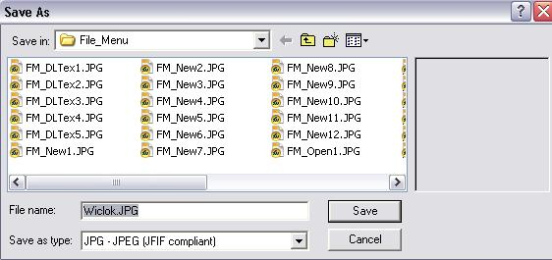

Lets take a closer look at the “Save” window.

The white box with the downwards facing arrow in the right-hand corner allows you to quickly navigate the data structure of your hard disks and other storage mediums. The text it currently displays is your current position.

The first icon an arrow pointing to the left is currently unavailable. It’s unavailable as we have not moved to another area on our storage medium. The arrow allows you to quickly return to a previous location you visited. As we have only visited this one location there are no previous ones for us to move too.
The second icon move up one level of the data structure with each press.
The third icon creates a new folder at your current level in the data structure.

The forth icon allows you to change how the contents pane displays the files. Try a few of the options to see how it works.

Tutorial continued on next page.
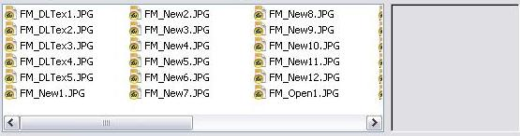

The large white area with the smaller grey area to the right of it is the contents pane - in here you can see a list of files. The grey area is a preview pane that shows you what a selected image looks right to help you determine if you want to overwrite a file, if you don't want to overwrite a file do not select a file in this pane.

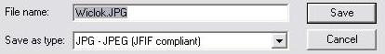

The last part of the window allows you to do three things.
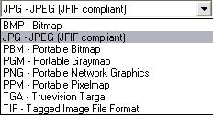
1). Name your file for saving in the file name entry box.
2). Change the type - this allows you to save a loaded file in a number of different formats.

Click the downwards pointing arrow at
the right of the box to see the list of
available formats:

3). Cancel and not save at all.
The save will not actually be performed until you click the save button.
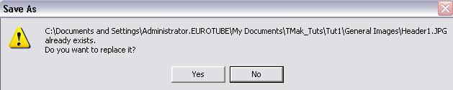
If you get this message after clicking the save button:
You have picked a file name that is already in existence. When you click Yes the file is overwritten. This process is not reversible so please be careful when saving over existing files.
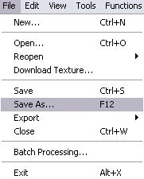
File Menu – Save As.

The sixth option on the “File” menu is “Save As”.

As with “Save” it can appear both active as above and inactive(gray) – see “Save” option for a detailed explination.

“Save As” functions almost the same as “Save”, in fact if you try to save a texture over an existing file it is the “Save As” dialogue box that appears and not the “Save” box. “Save As” allows you to save a texture under a different name. Unlike “Save”, “Save As” will always prompt for a file name. The steps for using “Save As” are identical to “Save”. Please refer to “Save” for instructions on saving a file.

Tutorial continues on next page.
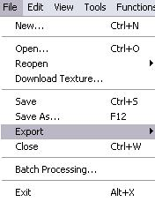
File Menu – Export.

The seventh option on the “File” menu is “Export”
and first appeared on version 1.7.

As with “Save” and “Save As” the “Export” option can only be used if a texture is currently loaded in the application. For this tutorial I am assuming a texture is already loaded.

If you have been observant you will notice that “Export” has the same small black right pointing arrow as the “Reopen” option. Any menu which displays this small indicator is pointing out that the option leads to another menu.

Lets take a look at this secondary menu:

As the image above shows there are two export types available.

1). Normal Map – this is used to add additional detail to polygonal art. How this is achieved I will not cover only how to use the function.

2). Texture with Alpha Channel – saves a texture with an additional channel, the alpha channel is used to indicate an area of a texture that is transparent. Again how this works is not a subject of this tutorial only how to use the function.

The (TGA32) shown after each option is simply telling us what file format these exports will produce.

Lets start be taking a look at the “Normal Map” option. Highlight the option and press the left mouse button.

Tutorial continues on next page.

The following “Export” dialogue box appears:
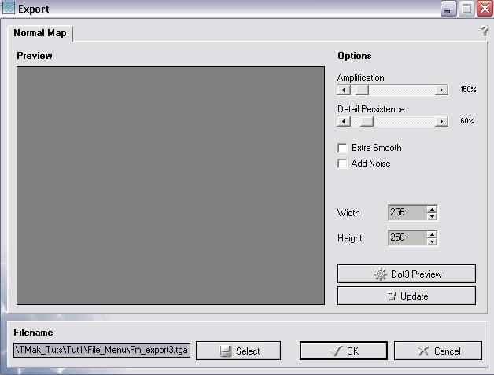

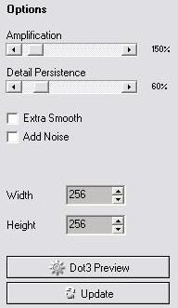
Lets take a look at the “Export” window in more detail.

The dark gray “Preview” pane is exactly as the
name suggests – gives a preview of the normal
map that will be exported.

To the left of the “Preview” pane we have
the “Options” panel →

1). “Amplification” adjusts how much
depth the normal map will convey.
2). “Detail Persistence” allows you
adjust how harsh the detail is to
to be applied to the normal map.

The best way to see what they do is to play
with the options and then left click the
“Update” button to show a preview.

3). “Extra Smooth” is a simple check box and if ticked will
Smooth the entire normal map. Here is an example:
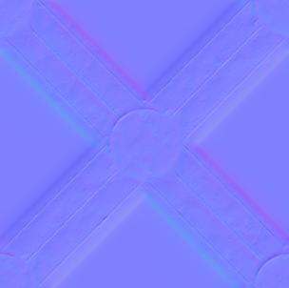


The left-hand image is without “Extra Smoothing”. As you can see all the edges of the normal map image have been made less obvious.

4). “Noise” again a simple check box only this time it adds
noise filter to the normal map. Again here is an example:
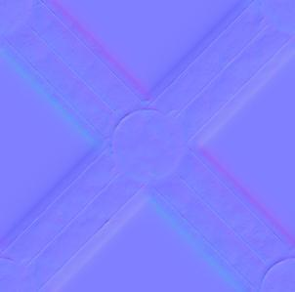

This time the left-hand image is without “Noise” applied. If you look carefully at the right-hand image you will see that a fine speckle has been added to the normal map. This is to help roughen the map.

5). “Width & Height” options – an easy one to explain. These
two entry boxes allow you to set the output size of the
normal map in pixels. In the case of my example 256 x 256.

6). The “Dot3 Preview” what this
feature does is generate an
animated preview of the normal
map with the light source turning a full 360 Deg. The
idea behind this is to give a better general view of
how the angle of light, will effect how the normal map
applies the detail. Try it to see.

7). The “Update” button generates a
preview of the normal map for
display in the “Preview” pane.
The “Preview” pane does not update automatically, so each
time you change a setting you must click this button. To
see the new version of the normal map in the “Preview” pane.

Now lets take a look at the final part.

The “Filename” portion of the normal map export window allows you to select where to save the normal map and what to call it.

1). The manual field box allows you type in the save path and a
name.

2). The “Select” button brings up the standard windows save
window as described in the “Save” option earlier in this
tutorial.

3). The “OK” button will save the file to the location shown in
the manual entry field.

4). The “Cancel” button and the “X” button in the top right-
hand corner perform the same function and will exit out of
the “Export” function. Only either of these buttons is
pressed you will need to reselect the function from the
menu.

Now for the second export feature:

You will need two textures ideally to use this feature, one the texture, and the other the alpha channel.

The current active texture in the main view serves as the texture, you have to select the other once the option is selected.

Once selected the following “Export” window appears:
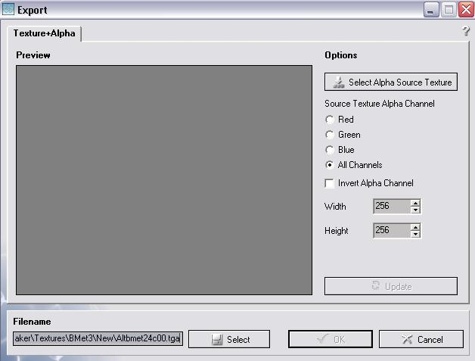

Note that the “Preview” pane is currently not showing a preview. You must first select the texture that will be the alpha channel before a preview is generated. To do this left click the “Select Alpha Source Texture” button to the right of the preview pane.

If you only have one texture currently loaded it is used as the texture. However if you have more than one texture loaded the following selection box will display showing a thumbnail of the currently open textures.

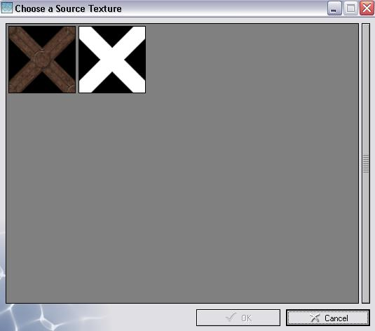

Simply double click on one of the
Thumbnails or left click once and
then click on the “OK” button.

In this example the black and white texture will be the alpha channel.

The “Preview” window updates with your selection:
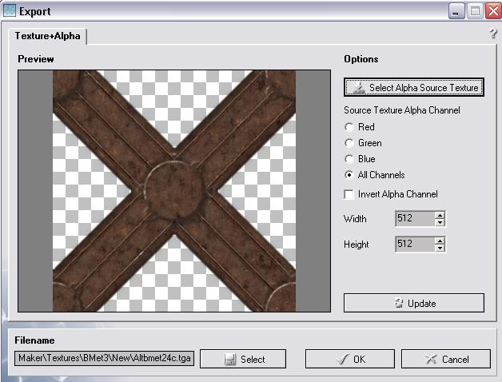

The area’s shown with a white and gray checker pattern are transparent, so they can be seen through.

Beneath “Source Texture Alpha Channel” there are 4 radio buttons and a check box. The radio buttons set which color channel will be used as the alpha channel – Red, Green, Blue, or All Channels. The check box inverts the alpha channel, see the before and after examples at the top of the next page to see invert in action.

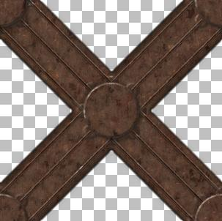

Before After

To give you a better understanding, below is the original texture.
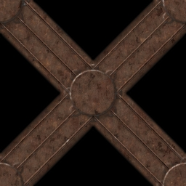

Next on the “Export” window are the “Width & Height” entry boxes, which allow you to specify the output files dimensions in pixels.

Last under the options section is the “Update” button which refreshes the “Preview” window with any changes you may have made in the options section. Remember that the “Preview” window does not automatically update, you have to press the “Update” button.

The last section on the “Export” window allows you to control where to save the texture and what to call it.

Under “Filename” is the manual entry field which allows you to type in the safe path and file name of the export.

The “Select” button next to the manual entry field brings up the standard windows save dialogue box. Refer to the “Save” option for details on how to use it.

The “OK” button saves the texture to the path and name shown in the manual entry box.

“Cancel” along with the “X” button in the top right-hand corner close the export function without exporting the file. You will need to select the export function again from the menu if you really want to export.

Tutorial continues on next page.
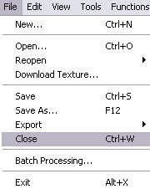
File Menu – Export.

The “Close” option on the file menu will close
the current active texture. IF the texture has
not been saved but has been altered since it was
either loaded or created you will be presented
with the following message:
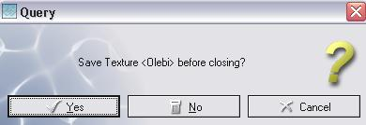

Clicking on the “Yes”
button opens the “Save”
dialogue box. (See the
section on saving for
further details).

Clicking on the “No” button will close the texture without saving it. This is not reversible so if you close a texture with “No” remember that it is lost, unless previously saved.

“Cancel” or the “X” in the top right-hand corner of the “Query” box exit the close routine and leave the texture open in the program.

Tutorial continues on next page.
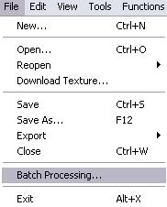
File Menu – Batch Processing.

The “Batch Processing” option on the menu
opens the following dialogue box.

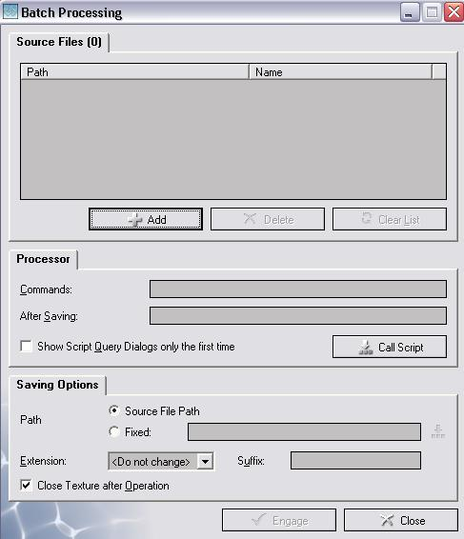

“Batch Processing” allows you
to run a task on more than
one texture.

You only need to provide a
list of files to be processed
and the function runs down
the list sequentially.

Lets take a closer look.
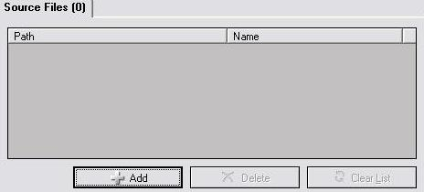

The top part of the window allows you to “Add”, “Delete”, and “Clear List” – this is the list of files to be processed.

Currently we have not selected any so the list is empty and options “Delete” and “Clear List” are unavailable.

Add a file to the list by clicking on the “Add” button.
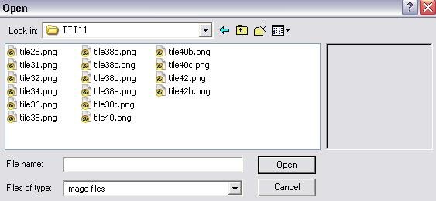

The “Open” dialogue box opens – for more information on how to use the “Open” dialogue box see the “Open” section earlier in this tutorial.

To select a file either double click it, or left click once and then left click on the “Open” button. If you want to select multiple files from the same directory. Either press and hold the “CTRL” key on the keyboard while you click each file, or if the files are in a range, click on the first one to select it, and then press and hold the “SHIFT” key on the keyboard, and click on the last file in the range. This will select all the files between the one you first selected and the one you clicked on last. Click the “Open” button once all the files you want have been selected in the directory.

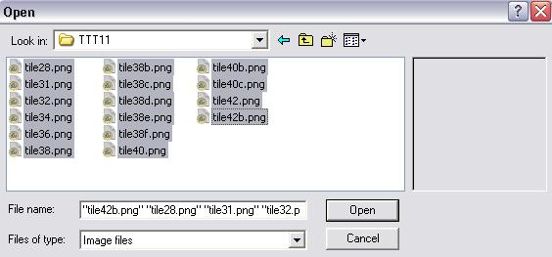
For this example I’m selecting all the files shown in the image below:

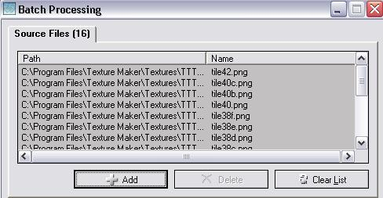
Once the “Open” button has been pressed the list is updated with your selection. If you want to add more files from the same or another location simply click the “Add” button again as we did a few moments before.

To delete an item from the list you must first select a file from the list, this enables the “Delete” button. Once you have selected a file or files simple press the “Delete” button to remove them from the list.

The “Clear List” button will empty all textures from the list giving you a clean place to start should you need to.

Now to move onto the next part of the “Batch Processing” window “Processor”.
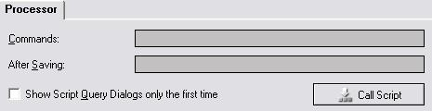

This section allows you to run scripts on the file list. Scripts are lines of code that instruct Texture Maker to run its various functions without you having to go and click on them. The “Commands:” entry field allows you to enter your script. The script is run on each of the selected files in turn and then the result is saved. While the “After Saving:” entry field allows you to set another script that will run after each file is saved.

The check box labeled “Show Script Query Dialogs only the first time” limits scripts from prompting for needed values after their initial run. So if you have a script that asks for a color before it runs, it will only ask once, the value entered at this stage is then retained and used on all subsequent files.

Last is the “Call Script” button. This allows you to use a script you have already created and saved.
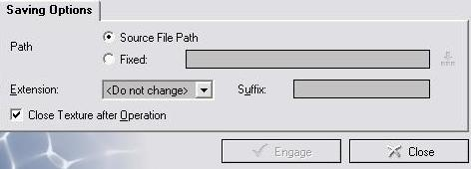

The end portion of the “Batch Processing” window is asking you where and how do you want the processed files saved.

You can see that there are two options against the “Path”, only one can active at any given time.

1). “Source File Path” – saved files will be placed in the
same location as the file that was just processed. So
The new file will appear in the same place as the old.
2). “Fixed” – you can specify an absolute path where all
processed textures will be saved regardless of the
location the original was loaded from. The entry box
to the right of the “Fixed” option shows the current
location if active, the symbol next to it allows you
to select the save location using the standard windows
selection dialogue.

Next is “Extension” currently set as “<Do not change>” this option allows you set a different type of file to save the processed files as.

“Suffix” adds a string of text to the name of the saved file, the string is added at the end of the loaded file name. If no “Suffix” is entered the save name remains unaltered from that of the original.

For example:

I have the files tile38b.png and floor.png selected for
processing and have entered the suffix as NT_isme. When
the processing has been run I end up with two files named
tile38bNT_isme.png and floorNT_isme.png

The final option in the window is “Close Texture after Operation”. If ticked this feature will automatically close the file it just processed. Unless you are only going to do a few at a time it is best to leave this option active. For every texture which remains loaded during the processing will slow the process down. Also note that when your machines memory limit is reached the program including your OS will likely crash.

Once you are happy with all the options click the “Engage” button.

If you click the “Close” button “Batch Processing” will close without running. You will need to select it again from the menus if you really want to run it.
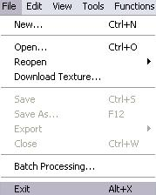
File Menu – Exit.

The final option on the “File” menu is the
end in more than one way. “Exit” instructs
the program to stop running and return you
to the OS.

If you have any modified and unsaved textures
you will be prompted to save them.

That concludes Part 1 of the Beginners Overview tutorial.

